Module 1 - Working with Text Boxes in MS Word

Introduction to MS Word and Marketing Designs
Microsoft Word is a popular word processing software used to create documents like letters, projects, reports, and marketing designs. It is part of Microsoft Office.

In MS Word, we can create attractive designs using tools like text boxes, shapes, pictures, tables, and text effects. These tools help us make posters, flyers, and brochures for marketing purposes.

To save a document in MS Word:
- Click on File → Save As
- Choose the location
- Enter the file name
- Click Save
The default file extension of MS Word is:
- .docx

Designing in MS Word means arranging text and visuals in a creative and neat way to make the document more attractive and easy to understand.

Definition of Insert Menu

The Insert Menu in MS Word is a feature that allows users to add various elements such as tables, images, charts, text boxes, and other objects into a document. This menu helps enhance the document's structure, readability, and visual appeal.
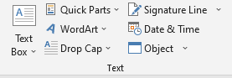
Text Elements
- Text Box – Adds a movable box for highlighting information.
- WordArt – Applies decorative text styles.
- Drop Cap – Enlarges the first letter of a paragraph for emphasis.
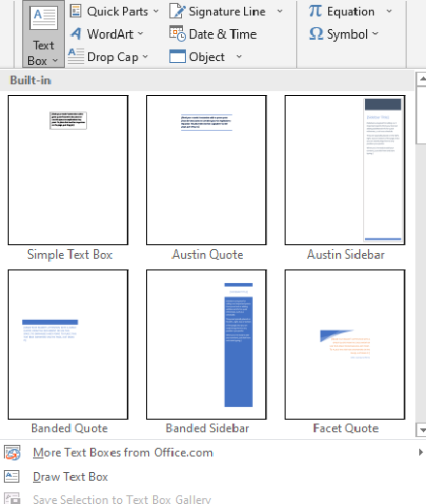
Text Box in MS Word
A Text Box in MS Word is a movable, resizable container used to insert and format text separately from the main document. It allows users to place text anywhere on a page, making it useful for highlights, callouts, and creative designs.
Use of Text Box:
A Text Box in MS Word is used to place text anywhere in a document, allowing better design, emphasis, and organization. It helps highlight important information, create callouts, and improve readability in reports, flyers, and presentations.
Save Selection to Text Box Gallery
The "Save Selection to Text Box Gallery" feature in MS Word allows users to save a customized text box for future use. This saves time by letting users quickly insert pre-designed text boxes instead of recreating them each time.
Helping Tool of Text Box
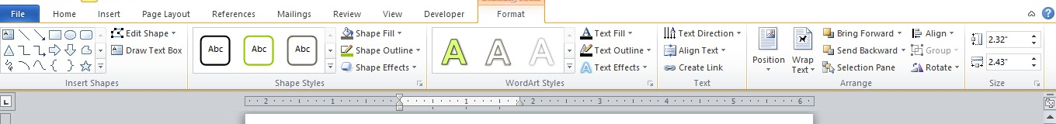
The Format Menu in MS Word provides tools to customize the appearance of text, images, shapes, and other elements in a document. It helps improve readability, design, and overall presentation.

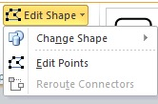
Edit Shape feature in MS Word

The "Edit Shape" feature in MS Word allows users to modify an existing shape by changing its form, adjusting its points, or converting it into another shape. This is useful for customizing diagrams, flowcharts, and creative designs.

Reroute Connectors

The "Reroute Connectors" feature in MS Word automatically adjusts the path of a connector (line linking two shapes) to find the shortest or most efficient route. This is especially useful in flowcharts, diagrams, and organizational charts where connectors need to avoid overlapping or tangled paths.
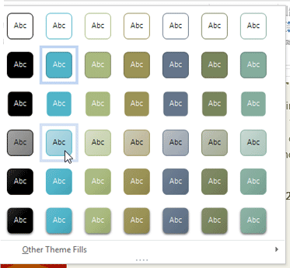
Shape Styles in MS Word

Shape Styles in MS Word are predefined formatting options that allow users to customize the appearance of shapes, such as rectangles, circles, and arrows. These styles help enhance the visual appeal of shapes by applying colors, outlines, and effects with just one click.

Shape Fill

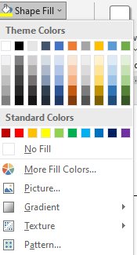
Shape Styles in MS Word are predefined formatting options that allow users to customize the appearance of shapes, such as rectangles, circles, and arrows. These styles help enhance the visual appeal of shapes by applying colors, outlines, and effects with just one click.

Shape Fill - Gradient
A Gradient in MS Word is a color effect that blends two or more colors smoothly within a shape. It enhances the visual appeal of shapes, making them more attractive and professional.
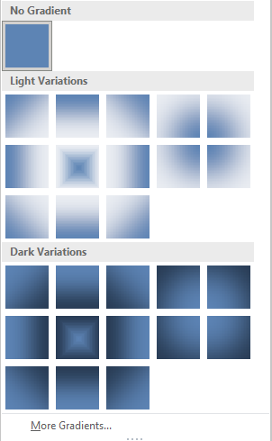

Shape Fill – Gradient – More Gradient

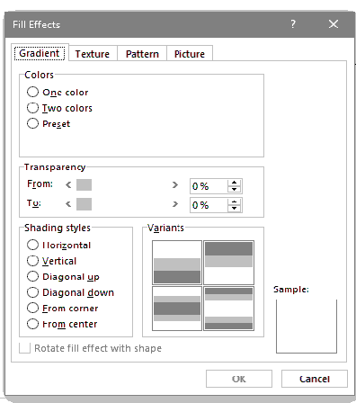
In Microsoft Word, a "gradient" typically refers to a gradient fill effect applied to shapes, text, or backgrounds. It creates a smooth transition between two or more colors, making the design look more attractive.

Customize the Gradient:
- Preset Gradients: Click on Preset colors to select a predefined gradient.
- Gradient Stops: Adjust colors and positions to create a custom gradient.
- Direction and Angle: Set the flow and orientation of the gradient.
- Transparency and Brightness: Modify these settings to achieve the desired effect.

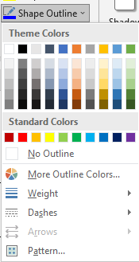
Shape Outline

In Microsoft Word, a shape outline refers to the border or the edge of a shape, such as a rectangle, circle, or any other shape inserted into the document. The outline helps define the boundaries of the shape and can be customized in terms of color, thickness, style, and other visual properties.

Shape Effects
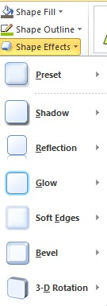
In Microsoft Word, Shape Effects are special visual enhancements that can be applied to shapes, such as text boxes, autoshapes, or drawn objects. These effects can make your shapes stand out and improve the overall design of your document.

WordArt Styles
WordArt Styles in Microsoft Word are pre-designed text effects that let you create decorative and visually appealing text. These styles include:
- Text Fill – Allows you to fill the text with solid colors, gradients, textures, or pictures.
- Text Outline – Adds a border around the text with different colors and thicknesses.
- Text Effects – Applies effects like shadows, reflections, glows, 3D rotation, and bevels.
- Transform – Lets you bend, stretch, or shape the text into different forms (e.g., wavy, circular).
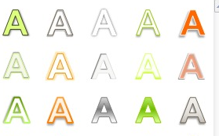
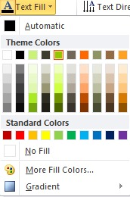
Text Fill
Text Fill is a formatting feature in Microsoft Word that allows you to change the color, gradient, texture, or even use an image inside the text. It is commonly used in WordArt to create decorative text.
Text Outline
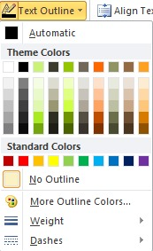
Text Outline is a feature in Microsoft Word that allows you to add a border or stroke around text. It is commonly used in WordArt to make text stand out with different colors, thicknesses, and styles.

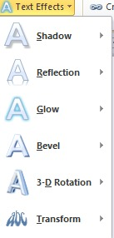

Text Effects
Text Effects in Microsoft Word allow you to add visual styles to your text, making it more attractive and eye-catching. These effects can be applied to both WordArt and regular text.
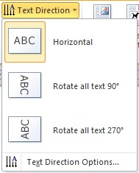
Text Direction
Text Direction in Microsoft Word allows you to change the orientation of text in tables, text boxes, and shapes. You can rotate the text vertically, horizontally, or at an angle.
Align Text
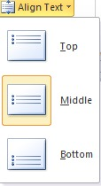
Text Alignment in Microsoft Word allows you to position text horizontally and vertically within a document, table, text box, or shape.
Create Link
You can add a hyperlink to text inside a text box in Microsoft Word to link to a website, email, another document, or a specific section within the same document.

Position feature in MS Word
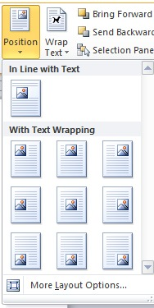
In Microsoft Word, you can control the position of text, text boxes, images, and other objects to create a well-organized document layout.

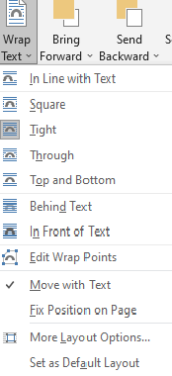
Wrap Text in MS Word
Wrap Text in Microsoft Word controls how text flows around images, text boxes, tables, and other objects. This feature helps position objects more flexibly within a document.
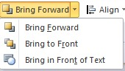
Bring Forward
The "Bring Forward" option in Microsoft Word is used to move objects (such as images, text boxes, shapes, or WordArt) to the front of the document layout, placing them above other elements.

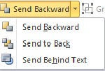
Send Backward
The "Send Backward" option in Microsoft Word is used to move objects (such as images, text boxes, shapes, or WordArt) behind other elements in a document. This helps organize overlapping objects.
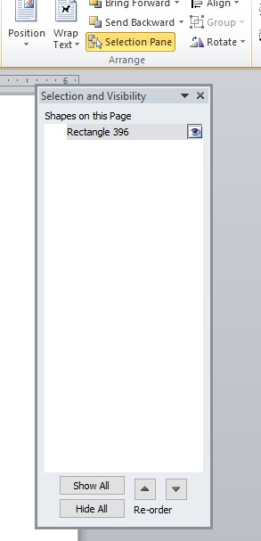
Selection Pane
The Selection Pane in Microsoft Word helps manage and organize multiple objects (such as images, text boxes, shapes, and WordArt) in a document. It allows you to select, hide, show, and reorder objects easily.
Group feature in MS Word
The Group feature in Microsoft Word allows you to combine multiple objects (such as images, text boxes, shapes, or WordArt) into a single unit. This makes it easier to move, resize, or format them.
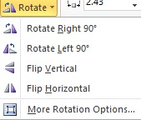
Rotate feature in MS Word
The feature in Microsoft Word allows you to turn objects such as images, text boxes, shapes, and WordArt to different angles for better design and alignment.
Align
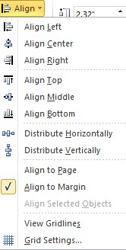
The Align feature in Microsoft Word helps position text, images, text boxes, shapes, and other objects neatly within the document. It ensures that elements are evenly spaced and properly arranged.
Height and Width
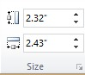
In Microsoft Word, you can adjust the height and width of images, text boxes, shapes, tables, and other objects to ensure they fit properly in your document.

Make this Assignment using Text Box in MS Word

