Module 6 - WhatsApp Marketing

WhatsApp Marketing is a type of digital marketing where businesses use WhatsApp to communicate with customers, promote products, send updates, and provide customer support.

In simple words:
WhatsApp marketing = Using WhatsApp messages to promote a business and interact with customers.

Businesses send messages such as:
- Product offers
- Order updates
- New product announcements
- Customer support replies
Example message:
“Hi! 🎉 Get 30% OFF on all shirts today. Reply YES to order.”

Why Businesses Use WhatsApp Marketing?
Businesses use WhatsApp because:
📱 Many people already use WhatsApp daily
⚡ Messages are delivered instantly
💬 Two-way communication (customers can reply)
📸 Supports images, videos, and documents
📊 Very high open rate (often above 90%)
Example:
A restaurant sends menu pictures and offers to customers on WhatsApp.

Types of WhatsApp Marketing
1. Promotional Messages
Businesses send offers, discounts, and product promotions.
Example:
“Weekend Sale! 🛍️ Get 40% OFF on all items. Shop now.”
Purpose:
- Increase sales
- Promote products

2. Customer Support
Businesses answer customer questions through WhatsApp.
Example:
Customer:
“What is the delivery time?”
Business reply:
“Your order will arrive in 30 minutes.”
Many companies now use WhatsApp as customer service chat.

3. Order Updates and Notifications
Businesses send transactional updates about orders.
Example:
“Your order #1234 has been shipped and will arrive tomorrow.”
Purpose:
- Keep customers informed

4. Broadcast Messages
Businesses can send one message to many customers at once using the broadcast feature.
Example:
“New summer collection launched! Check it out now.”
Important:
Customers must save the business number to receive broadcast messages.

5. WhatsApp Groups Marketing
Businesses create groups with customers to share updates and offers.
Example uses:
- Online courses
- Community groups
- Product launches
Example message:
“Group members get 20% exclusive discount today!”

Tools Used for WhatsApp Marketing
Businesses often use the official business version:

WhatsApp Business
This app is designed for businesses.
Features:
- Business profile
- Quick replies
- Automated messages
- Product catalog
- Labels for customers
Example:
A shop can show its product catalog directly in WhatsApp chat.

Example of WhatsApp Marketing
Business: Clothing Store
Message:
“Hi Rahul! 👕 Our new summer collection is here. Get 25% OFF today. Visit our store or reply to order.”
Purpose:
- Personal message
- Promotion
- Direct interaction

Advantages of WhatsApp Marketing
- Very high message open rate
- Supports images, videos, and voice messages
- Direct conversation with customers
- Low marketing cost
- Builds strong customer relationships

Disadvantages of WhatsApp Marketing
- Customers may block messages if overused
- Requires customer phone numbers
- Messages must follow WhatsApp rules

Difference Between WhatsApp Marketing and SMS Marketing
Both SMS Marketing and WhatsApp Marketing are used by businesses to communicate with customers through mobile phones, but they work in different ways.

Feature | SMS Marketing | WhatsApp Marketing
Platform | Uses mobile network SMS | Uses internet through WhatsApp
Content Type | Only text messages | Text, images, videos, documents, voice
Internet Required | ❌ No internet needed | ✔ Internet required
Interaction | Mostly one-way communication | Two-way conversation (chat)
Message Length | Usually 160 characters | Longer messages possible
Cost | Paid per SMS | Usually cheaper or free via internet

Simple Example
SMS Marketing Example
“Flash Sale! Get 30% OFF today. Visit our store now.”

WhatsApp Marketing Example
“Hi Rahul! 🎉 Get 30% OFF on our new shirts today. See our catalog here.”
WhatsApp allows images and product catalogs, making it more interactive.

Platforms Used for WhatsApp Marketing
1. WhatsApp Business
🔗 Official website: https://business.whatsapp.com/

What it is
This is the official business version of WhatsApp designed for small businesses.
Main Features
- Create a business profile (name, address, website)
- Send messages to customers
- Create product catalogs
- Use quick replies and auto messages
- Send broadcast messages to many customers

Example
A clothing shop sends:
“Hi! 👕 New summer collection launched today. Get 20% OFF.”
Best for
- Small businesses
- Local shops
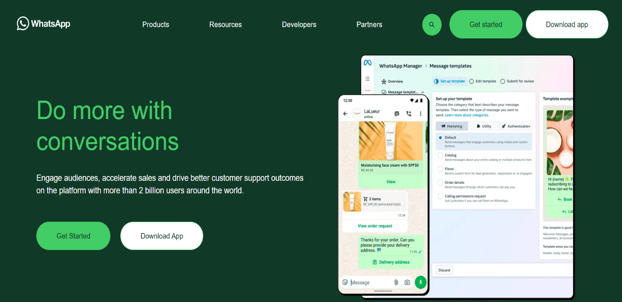
- Restaurants

2. WATI
🔗 Official website: https://wati.io
What it is
WATI stands for WhatsApp Team Inbox.
It helps businesses send bulk WhatsApp messages and manage customer chats.
Main Features
- Bulk WhatsApp marketing campaigns
- Chatbots and automation
- Shared inbox for team members
- Broadcast messaging
- Customer analytics
WATI works on the WhatsApp Business API, which allows businesses to send large numbers of messages and automate conversations.
Example
An e-commerce company sends:
“Flash Sale! 🛍️ Get 40% OFF today. Click here to shop.”
Best for
- Medium businesses
- E-commerce stores
- Customer support teams
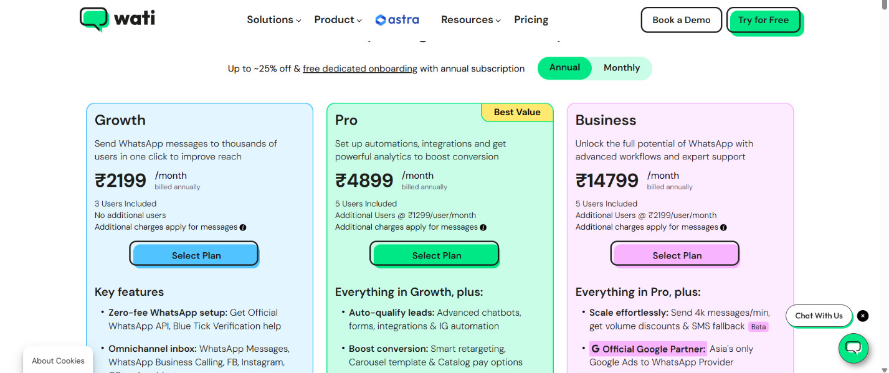

3. Twilio
🔗 Official website: https://www.twilio.com/whatsapp
What it is
Twilio is a cloud communication platform that allows companies to integrate WhatsApp messaging into their apps or websites.
Main Features
- WhatsApp API integration
- Automated messages
- OTP verification messages
- Chatbots and workflows
- Integration with CRM systems

Twilio allows developers to send and receive WhatsApp messages through the WhatsApp Business Platform API.
Example
A bank sends:
“Your OTP for login is 458912. Do not share it.”
Best for
- Large companies
- Developers
- Automated messaging systems
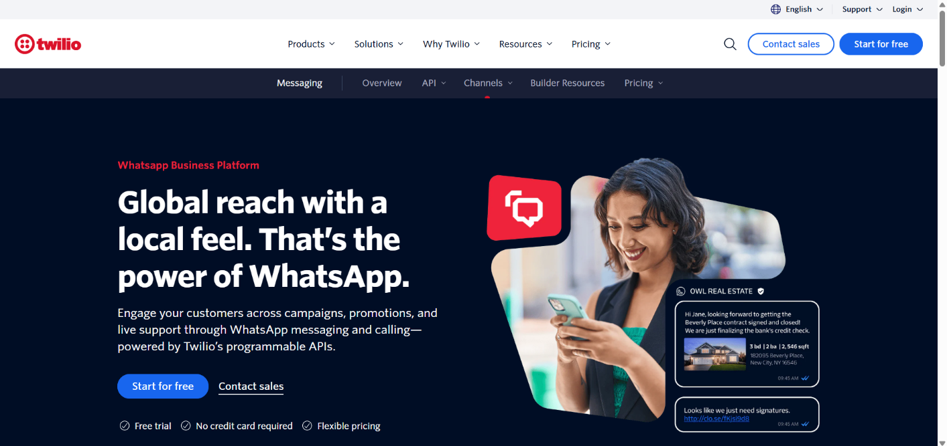

Assignment

Ques 1: What is WhatsApp Marketing?
A. Advertising on television
B. Using WhatsApp to promote products and communicate with customers
C. Sending letters through post
D. Posting ads in newspapers

Ques 2: Which of the following messages is an example of WhatsApp marketing?
A. “Hi! 🎉 Get 30% OFF on all shirts today. Reply YES to order.”
B. “Weather today is sunny.”
C. “Please turn off your phone.”
D. “This is a radio announcement.”

Ques 3: Why do businesses use WhatsApp marketing?
A. Because very few people use WhatsApp
B. Because WhatsApp messages are delivered instantly and allow communication with customers
C. Because it replaces websites completely
D. Because it works without phones

Ques 4: Which of the following content types can be sent through WhatsApp?
A. Only text messages
B. Only images
C. Text, images, videos, documents, and voice messages
D. Only voice messages

Ques 5: Which type of WhatsApp message is used to promote products or discounts?
A. Transactional message
B. Promotional message
C. Alert message
D. Security message

