Advanced Canva Features

1. Introduction to Advanced Canva Features
Canva provides advanced tools that help users create professional designs quickly. These features improve creativity, efficiency, and presentation quality without needing advanced design software.

2. Using Magic Design (AI Tools)
Magic Design is Canva’s AI-powered tool that automatically creates designs.
Features of Magic Design:
- Generates layouts based on text or images
- Suggests colors, fonts, and styles
- Saves time and effort
How to Use Magic Design:
- Open Canva
- Click Magic Design
- Enter text or upload an image
- Canva generates multiple design options
- Select and edit the best design
Benefits:
- Ideal for beginners
- Quick design creation
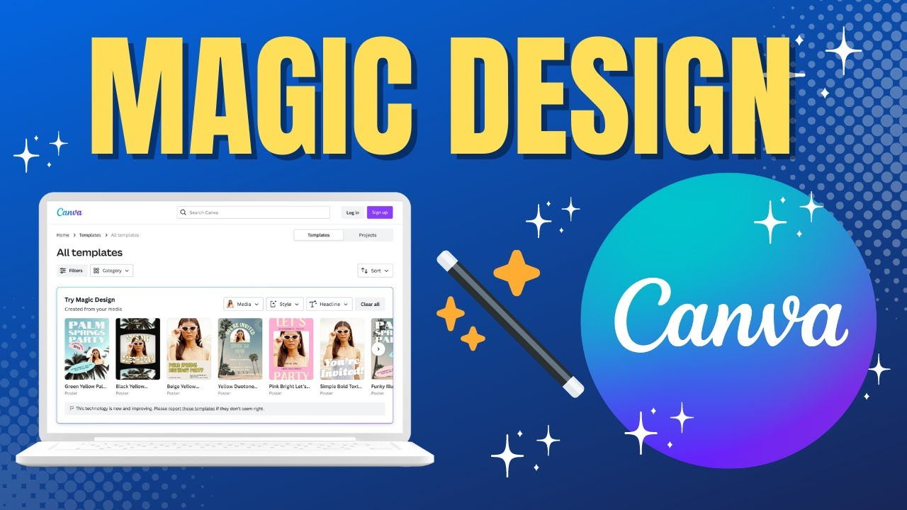
- Creative inspiration

3. Working with Layers & Transparency
Layers in Canva
- Each element (text, image, shape) is a separate layer
- Layers control which element appears on top or behind
Layer Options:
- Position (Forward / Backward)
- Lock and unlock elements
- Group and ungroup items
Transparency
- Controls how visible an element is
- Useful for watermarks and background effects
How to Adjust Transparency:
- Select the element
- Click Transparency icon
- Adjust the slider

4. Creating Animations & Motion Graphics
Animations add movement to designs and make them engaging.
Types of Animations:
- Text animations
- Element animations
- Page animations
How to Add Animation:
- Select text or element
- Click Animate
- Choose animation style
- Adjust speed if required
Uses:
- Social media posts
- Presentations
- Short videos
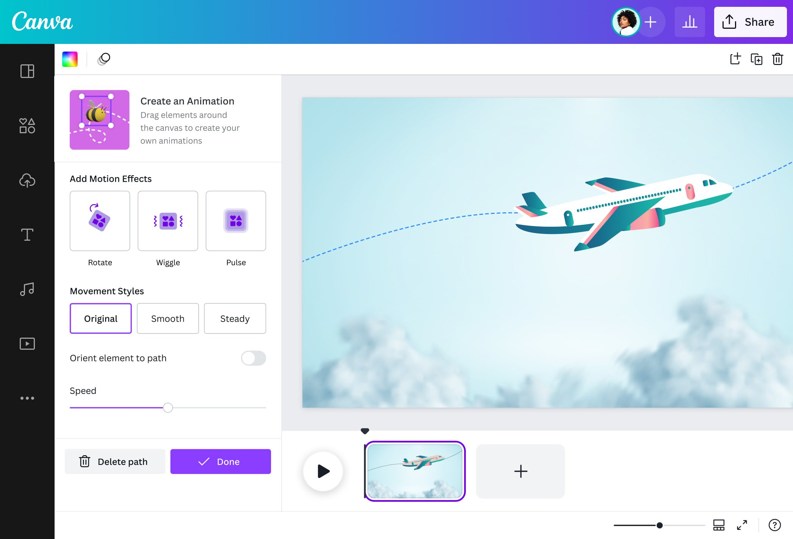

5. Designing Presentations in Canva
Canva offers ready-made presentation templates.
Features:
- Professional slide designs
- Animations and transitions
- Charts and icons
Steps to Create a Presentation:
- Open Canva
- Select Presentation
- Choose a template
- Add text, images, and charts
- Apply animations and transitions
- Present or download
Advantages:
- Easy to use
- Visually attractive
- Supports collaboration

6. Downloading Designs in Canva
Canva allows downloading designs in different formats.
Download Formats:
- JPG – Best for photos and web use
- PNG – High quality, supports transparent background
- PDF (Standard) – For sharing and online viewing
- PDF (Print) – High quality for printing
- MP4 – For animated videos
- GIF – For short looping animations
Download Steps:
- Click Share
- Select Download
- Choose file format
- Select pages (if needed)
- Click Download

7. Advantages of Advanced Canva Features
- AI-powered design tools
- Professional-quality output
- Saves time and effort
- Suitable for presentations, videos, and social media
- No advanced design skills required

Assignment: "Water Everywhere" Poster

Steps to Create in Canva:
- Access Magic Design:
  - Go to the Canva Home Page.
  - Click on the Search Bar at the top.
- Enter Your AI Prompt:
  - Type: "A professional poster about water everywhere, focusing on water conservation and blue aesthetic" or simply "Water Everywhere Poster."
  - Press Enter.
- Filter for Magic Design:
  - On the results page, look for the "Magic Design" banner or section. It will show you several custom-generated templates based exactly on your words.
- Select and Customize:
  - Pick the AI-generated design that you like best.
  - Click "Customize this template."
- Refine with AI Tools:
  - Magic Media: If you want a specific image of water (like "crystal clear ocean waves in 3D"), go to the Apps tab, select Magic Media, and type your prompt to generate a unique AI image.
  - Magic Write: Click on any text box and select Magic Write to have the AI help you write a catchy slogan like "Every Drop Counts: Protecting Our Blue Planet."
- Download:
  - Click Share > Download.
  - Select PDF Print (best for posters) or PNG.

  - 