Module 3 - Shape Manipulation & Pathfinder Operations

Introduction: What is Shape Manipulation?
In Adobe Illustrator, once you draw a shape, you’re not stuck with it.
You can:
- Move, resize, rotate, reflect, and distort shapes
- Combine multiple shapes into one
- Subtract or cut shapes apart
- Build custom icons and complex artwork
These tasks fall under shape manipulation, and Illustrator gives you powerful tools like the Transform tools, Pathfinder, and Shape Builder Tool to do them.

Transform Tools – Resize, Rotate, Reflect
These tools allow you to change the position, angle, or size of a shape.
✅ A. Selection Tool (V)
- Move and resize shapes quickly
- Drag corners to scale
- Hold Shift to scale proportionally

✅ B. Rotate Tool (R)
- Click on the shape → then drag to rotate
- Use Alt + Click to rotate by a precise angle
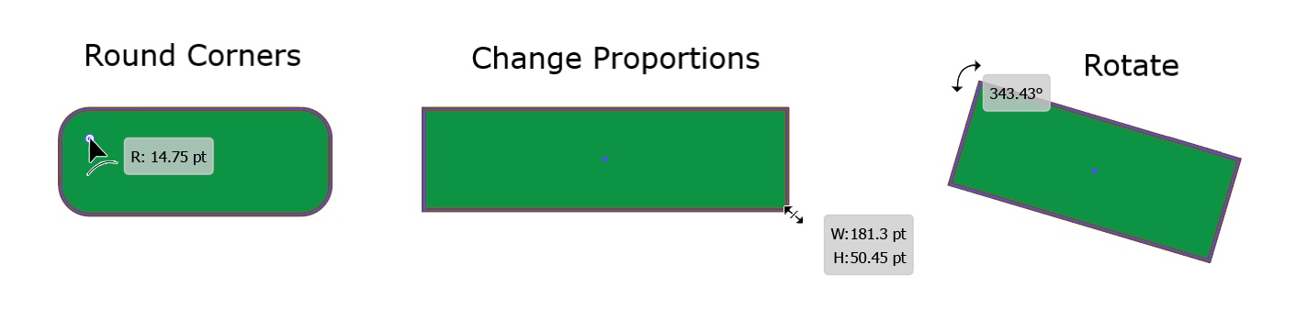

✅ C. Reflect Tool (O)
- Reflect (flip) an object horizontally or vertically
- Useful for symmetrical designs like wings, leaves, or faces

✅ D. Transform Panel (Window > Transform)
- Enter exact values for position, width, height, rotation, and reflection
📌 Tip: Use the bounding box to rotate and resize directly.

Pathfinder Panel – Combine or Cut Shapes
The Pathfinder Panel allows you to create new shapes by combining two or more basic ones.
How to Access:
- Go to Window > Pathfinder
Common Pathfinder Functions:

Tool | What It Does
Unite | Merges all selected shapes into one
Minus Front | Subtracts the front shape from the back shape
Intersect | Keeps only the overlapping area
Exclude | Removes the overlapping part
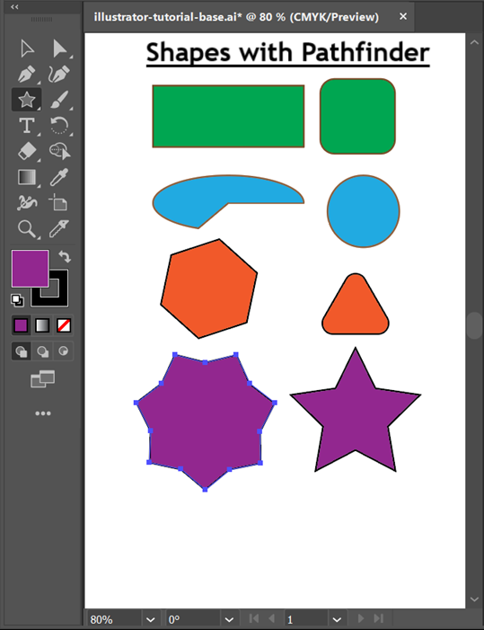
➤ Example:
- Use Unite to combine two overlapping circles into one large blob
- Use Minus Front to cut a star-shaped hole out of a circle
📌 Tip: Pathfinder is great for logo design, badges, and icons.

Shape Builder Tool (Shift + M)
This tool is one of Illustrator's most powerful features.
It lets you draw new shapes by merging or erasing overlapping parts — all with your mouse.
➤ How to Use:
- Select multiple overlapping shapes
- Choose the Shape Builder Tool (Shift + M)
- Hover over areas — they get shaded
- Click to merge shapes together
- Alt + Click to delete unwanted sections
💡 You can drag across shapes to merge them all at once.

➤ Example:
Create a petal by overlapping two ellipses:
- Use Shape Builder Tool to combine the center part
- Delete the outer extras with Alt + Click
📌 Best for creating custom icons and decorative elements.

Real-World Uses
- 🧩 Create complex logos using simple shapes
- 🖼️ Cut out portions of designs (e.g., holes, borders)
- 🌀 Design patterns, icons, UI buttons
- 🎯 Align and distribute multiple shapes accurately

Other Tools
The following are some of the other miscellaneous Adobe Illustrator Tools.

- Artboard Tool (Shift + O)
The Artboard Tool (Shift + O) allows you to create and manipulate artboards, which serve as the canvas for your illustrations.

- Hand Tool (H)
The Hand Tool (H) lets you navigate your document quickly by dragging it to view different areas.

- Zoom Tool (Z)
The Zoom Tool (Z) allows you to zoom in and out on your artwork for precise editing.

- Eyedropper Tool (I)
The Eyedropper Tool (I) samples colours and attributes from one object and applies them to another.

- Gradient Tool (G)
The Gradient Tool (G) helps you create and edit gradients, adding depth and dimension to your artwork.

- Shape Builder Tool (Shift + M)
The Shape Builder Tool (Shift + M) lets you combine and divide shapes easily to create complex forms.

- Eraser Tool (Shift + E)
The Eraser Tool (Shift + E) removes parts of paths or shapes, allowing for precise editing.

- Scissors Tool (C)
The Scissors Tool (C) cuts paths at specific anchor points, enabling you to create separate segments.

- Blend Tool (W)
The Blend Tool (W) creates smooth transitions between objects, making it ideal for creating gradients and special effects.

Assignment

Scenario: You’re creating a custom logo for a travel agency called "SkyRoutes."
Tasks:
- Open a new Illustrator document
- Draw:

  - A circle (sun)
  - A triangle (mountain)
  - A rounded rectangle (ticket)
- Use:
  - Pathfinder – Unite to merge mountains
  - Minus Front to cut out a plane shape from the sun
  - Shape Builder Tool to clean up or create unique combinations
- Reflect the design if needed to create symmetry
- Add color and export

