Module 10 – ER Model to Relational Model

What is the ER Model?
ER Model stands for Entity-Relationship Model. It is a conceptual design used to describe the structure of a database before implementing it.
- Entities: Things or objects (like Student, Course)
- Attributes: Properties of entities (like Name, Age)
- Relationships: Associations between entities (like a Student "enrolls in" a Course)
This model is typically drawn as an ER diagram to visualize how data is related.

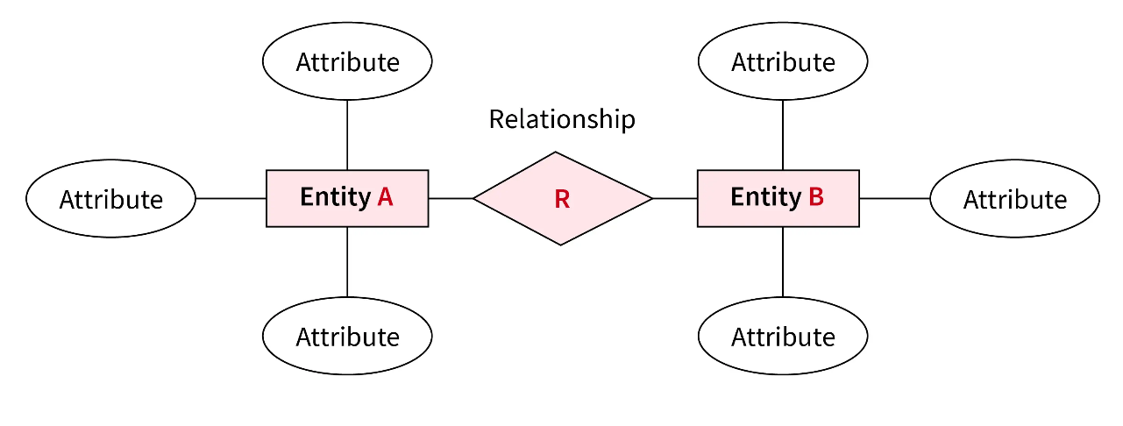

What is the Relational Model?

The Relational Model is how data is stored in relational databases like MySQL, Oracle, or PostgreSQL. It uses tables to store data, with rows as records and columns as attributes.
To implement a database, the ER model needs to be converted into the relational model.

How to Convert ER Model to Relational Model
Here’s how each part of the ER model is converted:

1. Entity to Table
- Each entity becomes a table.
- Each attribute becomes a column.
- Choose one attribute as the primary key.
Example:
- Entity: Student
- Attributes: RollNo, Name, Age
Relational Table:
Student(RollNo, Name, Age)
Here, RollNo is the primary key.

2. Attributes
- Simple Attributes: Directly become columns.
Example: Name, Age
- Composite Attributes: Break them into smaller attributes.
Example: FullName → FirstName, LastName
- Derived Attributes: These are calculated and usually not stored.
Example: Age (can be derived from Date of Birth)

3. Relationship to Table or Foreign Key
How you handle relationships depends on their type.

Case 1: One-to-One (1:1)
Add a foreign key in either of the tables.
Example:
Student(RollNo, Name)
StudentIDCard(CardNo, IssueDate)
If one student has one ID card, you can add CardNo as a foreign key in the Student table.

Case 2: One-to-Many (1:N)
Add a foreign key in the table on the "many" side.
Example:
Department(DeptID, DeptName)
Professor(ProfID, Name, DeptID)
A department has many professors, so DeptID is added as a foreign key in the Professor table.

Case 3: Many-to-Many (M:N)
Create a new table for the relationship.
Example:
Student(RollNo, Name)
Course(CourseID, CourseName)
Enrolls(RollNo, CourseID, Date)
The "Enrolls" table includes the primary keys of both Student and Course as foreign keys, and together they form a composite key.

4. Multivalued Attributes
For attributes that can have multiple values, create a separate table.
Example:
Student(RollNo, Name)
StudentPhone(RollNo, Phone)
This way, each student can have multiple phone numbers.

Example
ER Model Description:
- Entities: Student and Course
- Attributes:
  - Student: RollNo (primary key), Name
  - Course: CourseID (primary key), CourseName
- Relationship: Enrolls (many-to-many), with attribute EnrollmentDate

Relational Tables:
- Student(RollNo, Name)
- Course(CourseID, CourseName)
- Enrolls(RollNo, CourseID, EnrollmentDate)

In the Enrolls table:
- RollNo and CourseID are foreign keys
- Together they form the composite primary key

Assignment

Ques 1: Convert to Relational Table
Given Entity:
LibraryBook with attributes: BookID (primary key), Title, Author

Question: Write the relational table for this entity.

Ques 2: Identify the Entity, Attribute, and Relationship
Given:
A Student enrolls in a Course. Each Student has a RollNo and Name. Each Course has a CourseID and CourseName.
Questions:
- What are the entities in this example?
- What are the attributes of each entity?
- What is the relationship between them?

