Ques:- 1 Write a program where clicking a button displays a message on the screen.
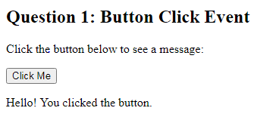
Output

Ques:- 2 Write a program that displays the text entered by the user in real-time.
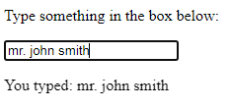

Output

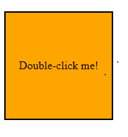
Ques:- 3 Write a program that changes the background color of a box when it is double-clicked.

Output

