Ques:- 1 Write code that takes a number (which can be negative and decimal) and shows its absolute value and the result of rounding it to the nearest integer.

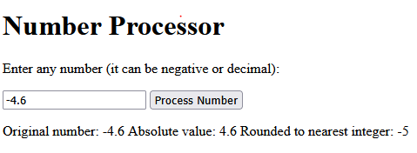
Output

Ques:- 2 Write a function that takes a number (must be non-negative) and returns: its square root (Math.sqrt) its cube root (Math.cbrt).

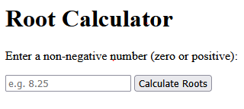
Output

