Ques:- 1 Write a function that uses a for loop to print numbers from 1 to 10.
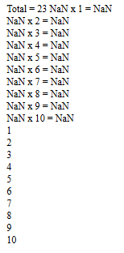

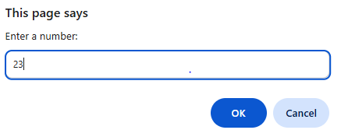
Output

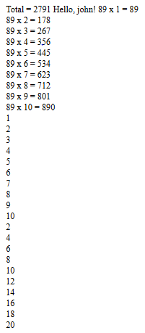
Ques:- 2 Write a function that uses a while loop to print all even numbers from 2 to 20.

Output

