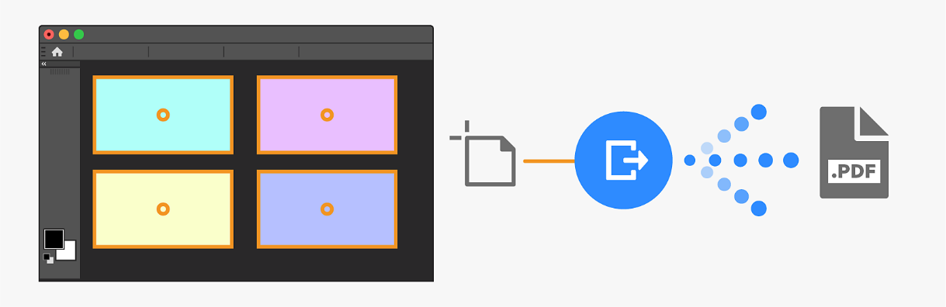

Create a New Document with Artboards
- Go to File → New
- Check the box “Artboards” (usually near the bottom of the New Document window)
- Set your dimensions (e.g., 1920×1080 px) and click Create.

Add Multiple Artboards
- In the Layers Panel, click the Artboard Tool (or press V and switch from Move Tool to Artboard Tool in the top bar)
- Click the + icons around the existing artboard to add more (as shown in your image: 4 artboards total)

Design Each Artboard
- Select each artboard individually and create your designs (e.g., colored rectangles, icons, text).
- Add different background colors and center elements as in the image:
- Light Blue, Purple, Yellow, and Light Violet backgrounds
- Orange stroke and center circle on each

Export as Multi-Page PDF
- Go to File → Export → Artboards to PDF…
- Choose:
- All Artboards
- Export Selected Artboards (optional)
- Set file name and location
- Enable “Include Background”

- Click Run
- Photoshop will compile all artboards into one multi-page PDF, as shown in your diagram.

