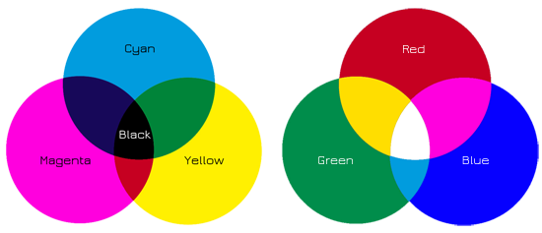

Create a New Document
- File → New → Set dimensions (e.g., 800x400 pixels) and a white background.

Create Three Overlapping Circles
- Use the Ellipse Tool (U), hold Shift to draw perfect circles.
- Make three circles with the following fill colors:
- Cyan: #00FFFF
- Magenta: #FF00FF
- Yellow: #FFFF00
- Arrange them so they overlap in the center.

Change Blending Mode
- Select all 3 circle layers.
- Set the Blending Mode to Multiply (in the Layers panel). This will simulate subtractive color mixing:
- Cyan + Yellow = Green
- Magenta + Cyan = Blue
- Magenta + Yellow = Red
- All three = Black

Label the Sections
- Use the Text Tool (T) to add labels:
- “Cyan”, “Magenta”, “Yellow”
- “Red”, “Green”, “Blue” (in overlaps)
- “Black” (center)

Duplicate the Circles or Create New Ones
- Create three new overlapping circles (or duplicate the old ones and change colors).
- Fill them with:
- Red: #FF0000
- Green: #00FF00
- Blue: #0000FF

Change Blending Mode
- Set their Blending Mode to Screen.
- Red + Green = Yellow
- Red + Blue = Magenta
- Green + Blue = Cyan
- All three = White

Label the Sections
- Use the Text Tool again:
- “Red”, “Green”, “Blue”
- “Yellow”, “Cyan”, “Magenta”
- “White” (center)

Final Touches
- Align everything nicely using the Move Tool and Alignment Options.
- Add any borders or background decorations if needed.
- Save your project:
- PSD (for future edits)
- PNG or JPEG (for submission)

