







Self-Made Assignment – MS Power Point
1
Using Screenshots and Comments in Power Point
o

Save this PowerPoint Presentation with the name of “Top Travel Destinations”
- Apply “Retrospect” Theme to all slides.
- Take Screenshot of different types of images and then insert from the insert tab "Images" group.

 | Slide 1: Title slide (name of the topic with description of the topic)
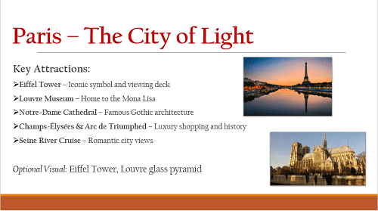 | Slide 2: Title and Content (About Paris and a picture of any destination)








Self-Made Assignment – MS Power Point
1
Inserting and Formatting Pictures in Power point

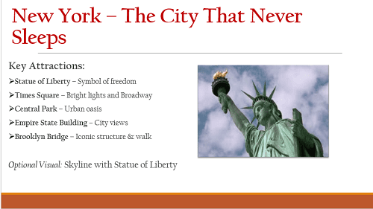 | Slide 3: Title and Content  (About New York and a picture of any destination)
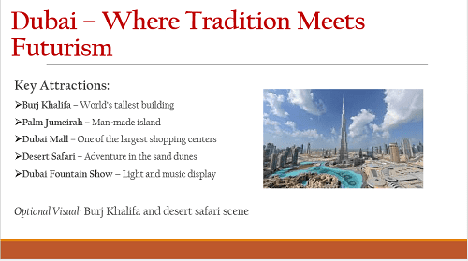 | Slide 4: Title and Slide  (About Dubai and a picture of any destination)






Self-Made Assignment – MS Power Point
1
Inserting and Formatting Pictures in Power point

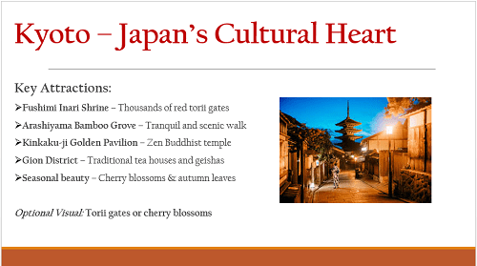 | Slide 5: Title and Content Slide (About Japan and a picture of any destination)
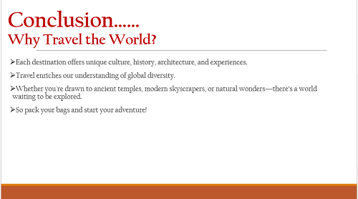 | Slide 6: Title and Content Slide (Add Conclusion at last)

