
A
Self-Made Assignment – MS Power Point
Inserting and Formatting Pictures in Power Point

Save this PowerPoint Presentation with the name of “Social Media”
- Apply “Adjacency” Theme to all slides.
- Download different types of images and then insert from the insert tab "Picture" group.

 | Slide 1: Title slide (name of the topic with description of the topic)
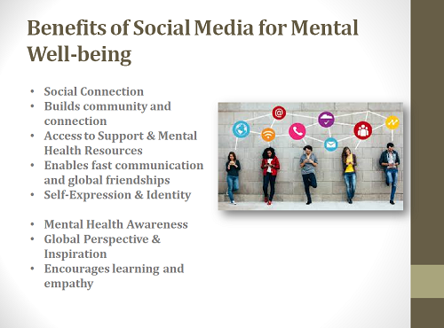 | Slide 2: Title and Content (Benefit of Social Media for Mental Well-being and add relevant image)

A
Self-Made Assignment – MS Power Point
Inserting and Formatting Pictures in Power point

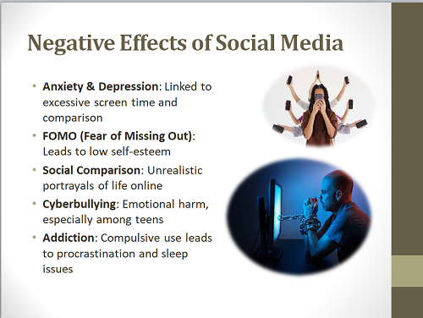 | Slide 3: Title and Content (Negative Effects of Social Media and add image according to you)
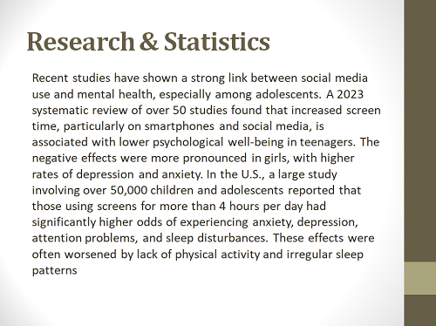 | Slide 4: Blank Slide  (Some Research and Statistics data)

A
Self-Made Assignment – MS Power Point
Inserting and Formatting Pictures in Power point

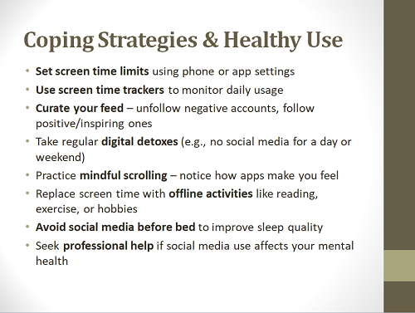 | Slide 5: Title and Content Slide (How we use it in a healthy way)
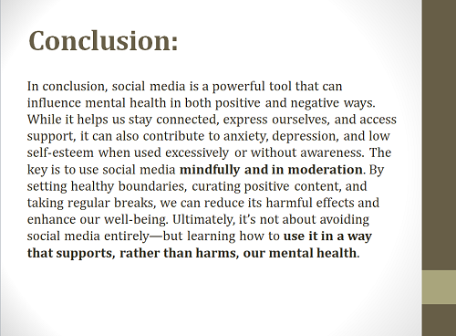 | Slide 6: Title and Content Slide  (Add Conclusion at last)

