
A
Self-Made Assignment – MS Power Point
Creating Photo Album using Slides

Save this PowerPoint Presentation with the name of “Our Solar System” and:
- Apply “View” Theme to all slides and Change the background color to grey.




- Add “Date and time” and “Slide number” from Header Footer option Under “Insert” tab.

 | Slide 1: Title slide (name of the topic )
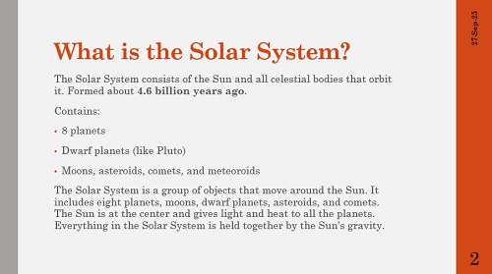 | Slide 2: Title and Content (Meaning of the Solar System)

A
Self-Made Assignment – MS Power Point
Inserting Current Date and Time and Slide Number in Power point

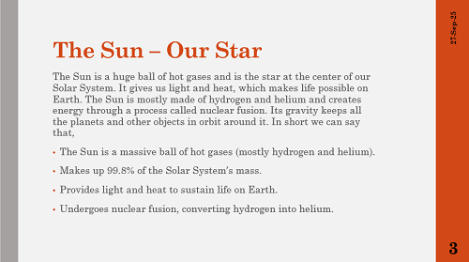 | Slide 3: Title and Content (Sun as a Star)
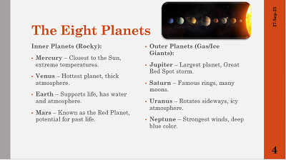 | Slide 4: Two content layout  (Names of all planets of our solar system,  Add image of solar system)

A
Self-Made Assignment – MS Power Point
Inserting Current Date and Time and Slide Number in Power point

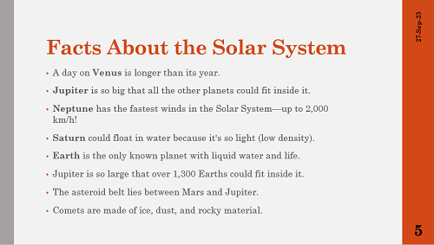 | Slide 5: Title and Content Slide (At last add Conclusion)
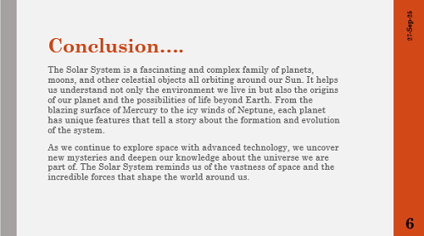 | Slide 6: Title and content  (Add conclusion about the topic)

