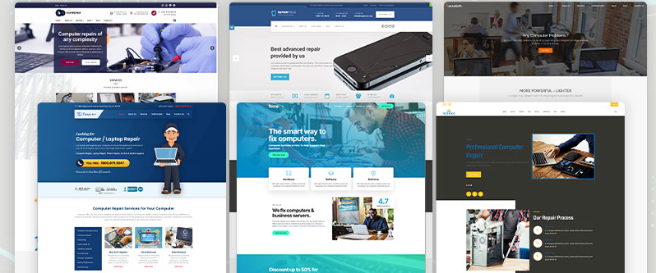

Create a New Document
- Open Adobe InDesign → File > New > Document.
- Set page size (e.g., A4 or Web 1366x768 if designing for digital).
- Set margins and columns for alignment.

Set Up Layout
- Use the Rectangle Frame Tool (F) to create placeholder boxes for images (like laptops, people, repair tools).
- Use the Type Tool (T) to create text boxes for headings, subheadings, and paragraphs.
- Arrange sections similar to the website templates shown (header, main body, footer).

Insert Images
- Go to File > Place → select images (like computer repair, laptops, technicians).
- Fit images using Object > Fitting > Fill Frame Proportionally.

Add Headings & Buttons
- Use bold fonts for headings (e.g., “Computer & Laptop Repair”).
- Draw button shapes with the Rectangle Tool (M), fill with color, and add text like “Book Now”.

Apply Styles
- Use Paragraph Styles for headings, subheadings, and body text.
- Use Color Swatches to keep the design consistent (blue, white, and grey tones, like in the sample).

Add Hyperlinks
- Select the text or button you want to make clickable (e.g., "Book Now").
- Go to Window > Interactive > Hyperlinks.
- In the panel, click New Hyperlink.
- Enter the URL (e.g., www.repairservice.com).
- Choose Appearance: Invisible Rectangle (or visible if you want underline).
- Repeat for all buttons (like Home, Services, Contact Us).

Navigation (Optional for Multi-page)
- If you make multiple pages (e.g., Home, About, Contact):
- Select text (e.g., “About Us”) → Hyperlinks panel → link to Page Number.

Preview the Hyperlinks
- Go to File > Export → choose Adobe PDF (Interactive).
- Open the exported PDF → check all hyperlinks (buttons and text should be clickable).

Final Touch
- Align all elements using Align Panel.
- Add icons or small graphics to make it look like a professional web template.

