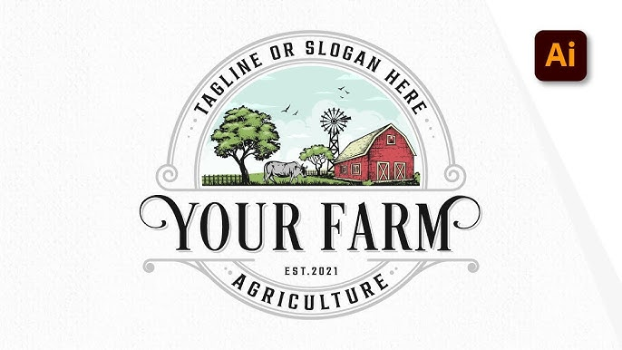

Create a New Document
- Open Adobe InDesign.
- Click File > New > Document.
- Set size (e.g. 1000px x 1000px or A4).
- Click Create.

Add Background (Optional)
- Use the Rectangle Tool (M) to draw a white background.
- Lock it if needed (Object > Lock > Selection).

- Place the Farm Illustration
- Use File > Place (Ctrl+D).
- Insert your farm scene illustration (SVG, PNG, or AI file).
- Resize and center it.
- If you want to draw it yourself: create the illustration in Adobe Illustrator, then export to PNG or AI and import it here.

Add the Upper Curve Text ("TAGLINE OR SLOGAN HERE")
- Select the Ellipse Tool (L).
- Draw a circle over the top of the farm image.
- Use the Type on a Path Tool (click and hold Text tool).
- Click on the circle path and type:
"TAGLINE OR SLOGAN HERE"
- Use Character panel to:
- Adjust font
- Increase tracking (spacing)
- Center align text

Add the Main Title ("YOUR FARM")

- Use the Type Tool (T).
- Click below the illustration and type:
"YOUR FARM"
- Choose a bold, vintage serif font.
- Increase font size and align to center.
- Add letter spacing to give it a classic logo feel.

Add the Lower Banner Text ("AGRICULTURE")
- Draw another small curved path under the farm image (use Ellipse tool again).
- Use Type on a Path Tool again.
- Type "AGRICULTURE" and format it similarly.

Add the "EST. 2021" Text
- Use the Type Tool (T) again.
- Click between the farm image and the lower text.
- Type "EST.2021"
- Center it and format with a small sans-serif font.

Add Decorative Elements (Swirls, Lines, etc.)
- Use Pen Tool (P) or download SVG flourishes online.
- You can also draw small ornaments in Illustrator and place them via File > Place.

Final Adjustments
- Align everything to center (select all → Align Center).
- Add space between elements for balance.
- Group related elements (Ctrl+G) to keep layout intact.
- Optional: Add a textured paper background for vintage look.

Export Your Work
- Go to File > Export.
- Choose PDF (Print) or PNG/JPG if required for submission.
- Set quality to High and export.

