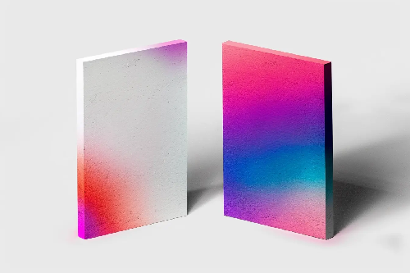
- Set Up the Document
- Open InDesign → File > New > Document.
- Choose your size (e.g., A4 or custom, depending on requirement).
- Set margins and bleed (if printing).
- Create the Poster/Board Shapes
- Use the Rectangle Tool (M) to draw two vertical rectangles (like posters/cards).Position them side by side with some space in between.

- Apply Gradient/Texture
- There are two approaches:
- Option A: Simple Gradient Fill
- Select a rectangle → open Gradient Panel (Window > Color > Gradient).
- Choose Linear or Radial gradient.
- Add multiple gradient stops with colors (pink, purple, blue, red, etc.) to match the effect.
- Adjust the Gradient Tool (G) direction for smooth blending.
- Option B: Gradient Image/Texture Import
- In Photoshop (or any editor), create a gradient texture (like in your image).
- Save it as a high-quality JPEG/PNG.
- In InDesign, File > Place and import it into the rectangle.
- Use Fitting > Fill Frame Proportionally to adjust.

- Add Shadow/Depth Effect (Optional)
- To give the 3D floating look:
- Select rectangle → Effects (Window > Effects).
- Apply Drop Shadow with soft blur.
- Adjust opacity and distance until it looks like the reference.
- Refine the Composition
- Rotate slightly if needed to mimic perspective.
- Use a gray background rectangle behind the posters for contrast.

- Export
- File > Export.
- Choose PDF (Print) for high-quality or PNG/JPEG for digital.

