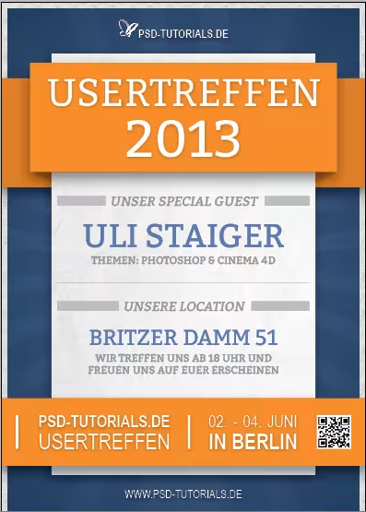

Set Up the Document
- Open Adobe InDesign.
- File > New > Document
- Orientation: Portrait
- Size: A4 (or your desired size)
- Margins: 20 mm (can adjust as needed)
- Bleed: 3 mm on all sides

Background Design
- Use the Rectangle Tool (M) to draw a full-page rectangle.
- Fill it with a dark blue gradient or texture (similar to the poster).
- Lock this background layer to avoid accidental movement:
- Right-click > Lock Layer

Add the Orange Banner (Top Section)
- Draw a rectangle across the top part (approx. 1/4 of the height).
- Color: #f7941d (or close to the orange tone).
- Add a smaller white rectangle slightly beneath it to mimic a shadow or card-layer effect.
- Use Effects > Drop Shadow if needed.

Text:
- "USERTREFFEN"
- "2013"
- Font: Bold Sans Serif (e.g., Bebas Neue, Montserrat, or Arial Black)
- Size: Large (adjust to fit)
- Alignment: Centered

Middle Card (White Box with Guest & Location)
- Draw a white rectangle centered below the orange banner.
- Add subtle drop shadow to give depth.
- "UNSER SPECIAL GUEST" (Gray, small caps)
- "ULI STAIGER" (Blue, bold, large)
- "THEMEN: PHOTOSHOP & CINEMA 4D" (Small gray text)
- "UNSERE LOCATION"
- "BRITZER DAMM 51"
- Additional Info: “Wir treffen uns ab 18 Uhr…” in small gray text
- Use paragraph spacing or line breaks to control the layout
- Center-align all text blocks

Bottom Orange Footer
- Add another orange rectangle at the bottom of the page.
- Divide it into three sections using vertical lines or spacing.
- Logo or text: "PSD-TUTORIALS.DE"
- Text: "USERTREFFEN"**
- Date: "02. - 04. JUNI"
- Location: "IN BERLIN"
- Insert a placeholder or real QR code
- Font: Sans Serif (consistent with header)
Text Color: White for contrast

Typography Notes
- Fonts: Use clean, bold sans-serif fonts.
- Colors: Use white, gray, blue (#3a4b7d), and orange (#f7941d).
- Emphasize key phrases using size and color.

Final Touches
- Align elements vertically using the Align Panel
- Use Smart Guides for spacing
- Group related elements (Ctrl/Cmd + G)
- Check margins and bleed
- Export: File > Export > PDF (Print) with bleed settings enabled

