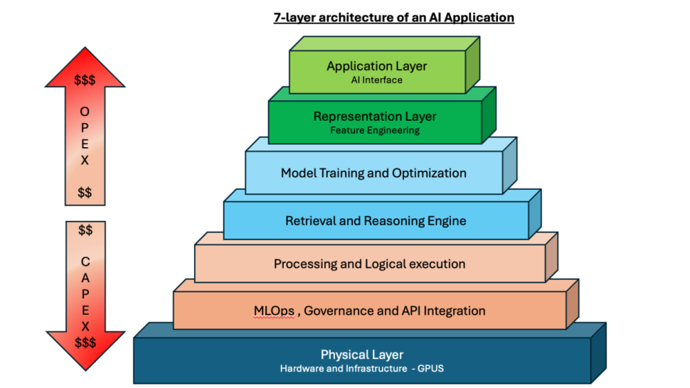

Set Up the Document
- Open Adobe InDesign.
- Go to File > New > Document.
- Choose a standard size (e.g., A4 or Letter).
- Set orientation to landscape (optional for better layout).
- Click Create.

Draw the Pyramid Layers

Use the Rectangle Tool (M):
- Start from the bottom layer (Physical Layer) and work upward.
- Draw each rectangle one above the other.
- Resize each rectangle smaller than the one below it (to form a pyramid).

Apply Color:
- Use the Swatches Panel to fill each layer with colors similar to the image.
- Bottom layer: Dark Blue
- Top layer: Light to dark green
- Middle layers: Various blue and peach shades

Add 3D Effect (Optional):
- For a 3D look, you can draw shadows or use Bevel and Emboss effects (via Effects > Object Effects > Bevel and Emboss).

Add Text to Layers
- Use the Text Tool (T).
- Click on each layer and type the corresponding label:
- Example: “Application Layer - AI Interface”
- Center the text using Align Panel.
- Adjust font, size, and color (prefer bold fonts like Arial Bold or Helvetica Neue).

Add OPEX & CAPEX Arrows
- Use the Polygon Tool to draw arrows:
- Hold Shift to draw straight vertical arrows.
- Fill with gradient red (top to bottom for OPEX, bottom to top for CAPEX).
- Use Text Tool to label the arrows:
- Write "OPEX $$$" going upward
- Write "CAPEX $$$" going downward

Rotate & Align Text:
- Use Type on a Path Tool (if using a path).
- Or rotate the text box (Object > Transform > Rotate).

Add Final Title
- Use the Text Tool to add:
- “layer architecture of an AI Application” at the top.
- Apply bold and underline styling.
- Center the title using the Align panel.

Export the Diagram
- Go to File > Export.
- Choose format: PNG, JPEG, or PDF.
- Name and save your file.

