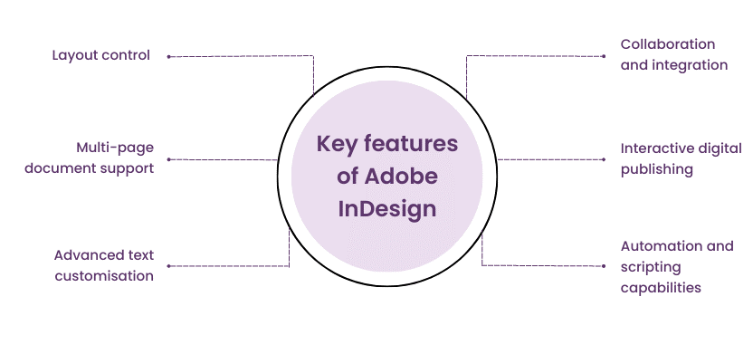

Create a New Document
- Open InDesign.
- Go to File > New > Document.
- Choose A4 or Custom Size (e.g., 1920x1080 px if it's for digital).
- Click Create.

Draw the Central Circle
- Select the Ellipse Tool (L).
- Hold Shift while dragging to make a perfect circle.
- Fill: Light Purple
- Stroke: Black or Dark Gray
- Align it to the center using Align Panel (Window > Object & Layout > Align).

Add the Center Text
- Use the Text Tool (T).
- Click inside the circle and type
- Font: A clean sans-serif (e.g., Montserrat, Arial, or Helvetica).
- Center-align the text.
- Adjust size to fit nicely inside the circle.

Add Side Text Features
- Use the Text Tool (T).
- Type each feature as separate text boxes:
- Left:
- Layout control
- Multi-page document support
- Advanced text customisation
- Right:
- Collaboration and integration
- Interactive digital publishing
- Automation and scripting capabilities
- Align the text boxes vertically on each side of the circle.

Draw Connecting Lines
- Use the Line Tool ().
- Draw dashed lines from each feature to the circle.
- Stroke settings:
- Color: Purple
- Type: Dashed
- Use Shift to keep lines straight.
- Customize Colors & Fonts
- Use Swatches Panel to define and apply:
- Purple tones (for text and lines)
- Light purple fill for the circle
- Keep the font consistent throughout.

Final Touches
- Ensure alignment using Smart Guides and Align Panel.
- Use Layers Panel to organize:
- Background
- Shapes
- Text
- Save your work: File > Save As (.INDD)

