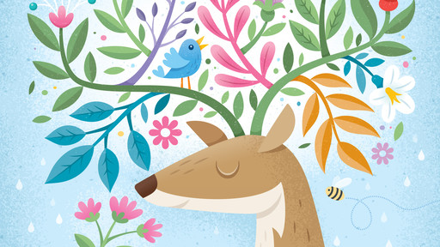

Create a New Document
- Open Adobe Illustrator
- File > New → Choose a canvas size (e.g., A4 or 1080x1080 px for digital)

Background Setup
- Use the Rectangle Tool (M) to draw a background rectangle.
- Apply a light blue gradient or texture to simulate the sky.
- Optionally, use the Effect > Texture > Grain for subtle texture.

Draw the Deer
- Use the Pen Tool (P) to outline the deer's body and face.
- Simplify the form with soft curves.
- Add ears and facial features (eye, nose) using the Ellipse Tool (L) and Pen Tool.
- Use Gradient or Flat Colors to shade.

Create Antlers from Tree Branches
- Use the Pen Tool (P) to draw organic, curving lines coming out of the head.
- These lines will serve as stylized branches/antlers.
- Add leaves using the Ellipse Tool or Pen Tool, adjusting the shape and color for variety.

Add Flowers, Birds, and Bees
- Flowers: Use combinations of ellipses and star shapes. Adjust petal count and colors.
- Bird: Use simple shapes (rounded ellipses, triangles for wings/beak) to form a cartoonish bird.
- Bee: Use ovals for the body, circles for the wings, and stripes with the Line Tool.

Add Decorative Elements
- Add water droplets, extra leaves, berries, etc., using simple shapes.
- Use Transparency/Opacity settings to layer elements softly.
- Group elements (Ctrl+G) as needed for easier management.

Organize with Layers
- Use the Layers Panel to separate:
- Background
- Deer
- Branches & Leaves
- Decorative elements

Color & Style
- Use Flat colors with no strokes or minimal outlines for a clean look.
- Maintain a cohesive color palette: pastels, earth tones, or playful hues.
- Use the Eyedropper Tool (I) to sample colors consistently.

Optional: Add Texture
- Use Texture Brushes or Opacity Masks to give it a natural, grainy look.

Export Your Work
- File > Export > Export As → Choose PNG, JPG, or SVG depending on use.
- Select “Use Artboards” to export only your canvas content.

