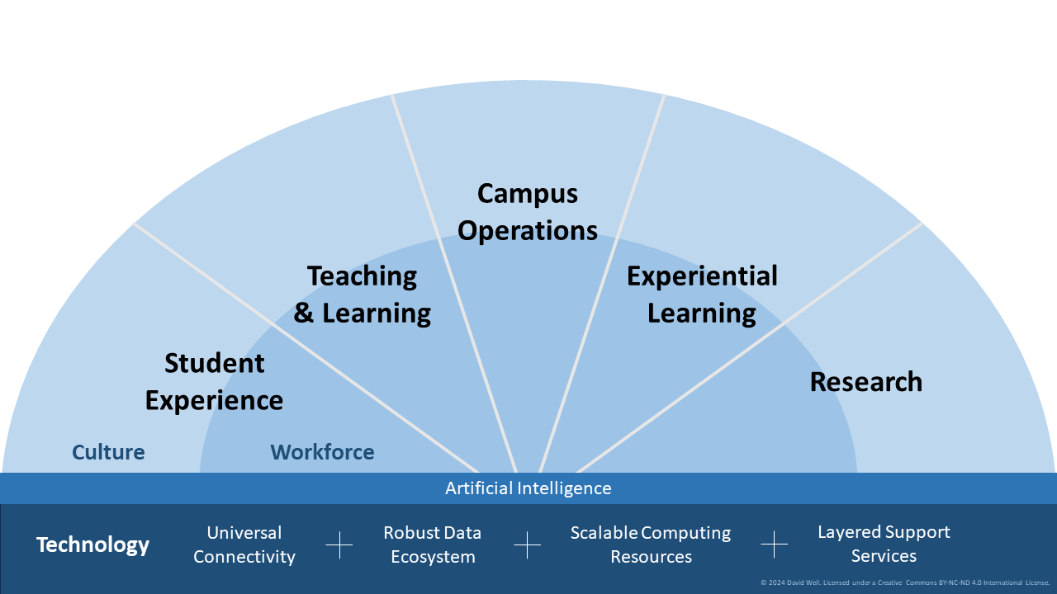

Set Up the Document
- Open Illustrator.
- New Document → Choose a landscape size (e.g., 1280 x 720 px or A4 landscape).

Create the Semi-Circle Base (Radial Background)

Draw the Outer Semi-Circle
- Select Ellipse Tool (L).
- Hold Shift + Alt and draw a perfect circle.
- Use the Direct Selection Tool (A) to remove the bottom anchor point.
- Fill with light blue.
- Align center to artboard.

Create the Inner Semi-Circle (Second Layer)
- Copy the outer semi-circle.
- Scale it down proportionally.
- Place it concentrically within the larger semi-circle.
- Use slightly darker blue.

Slice into Wedges (Sections)
- Use the Line Segment Tool (\).
- Draw lines from the center outward to divide the semi-circle into 5 sections.
- Use Rotate Tool (R) to rotate and copy lines at equal angles (~22.5° between each if you're making 5 equal wedges).

Add Section Titles
- Use the Type Tool (T).
- Add bold titles:
- Student Experience
- Teaching & Learning
- Campus Operations
- Experiential Learning
- Research
- Place them within each wedge.
- Use bold, legible font (e.g., Arial Bold or Source Sans Pro).

Add Subsection Labels (Culture, Workforce, etc.)
- Add smaller text near the bottom of each wedge, just above the AI band:
- Culture
- Workforce
- (Middle one doesn't need)
- Innovation
- Discovery

Add the Artificial Intelligence Band
- Use the Rectangle Tool (M) to draw a horizontal bar under the semi-circles.
- Label it: Artificial Intelligence
- Centered, white text on a dark blue bar.

Create Technology Base Section
- Add a darker rectangle below the AI band.
- Add the following items horizontally:
- Technology
- Universal Connectivity
- Robust Data Ecosystem
- Scalable Computing Resources
- Layered Support Services
- Use "plus signs" (+) as separators.
- Align text horizontally with even spacing.
- Consider small icons for visual aid (optional).

Colors and Final Touches
- Use varying shades of blue for depth.
- Consider using gradients for the semi-circles for a modern look.
- Adjust stroke weights for clean separation between wedges.

Save and Export
      - Save as .AI for editing.
      - Export as .PNG, .JPG, or .PDF for sharing.

