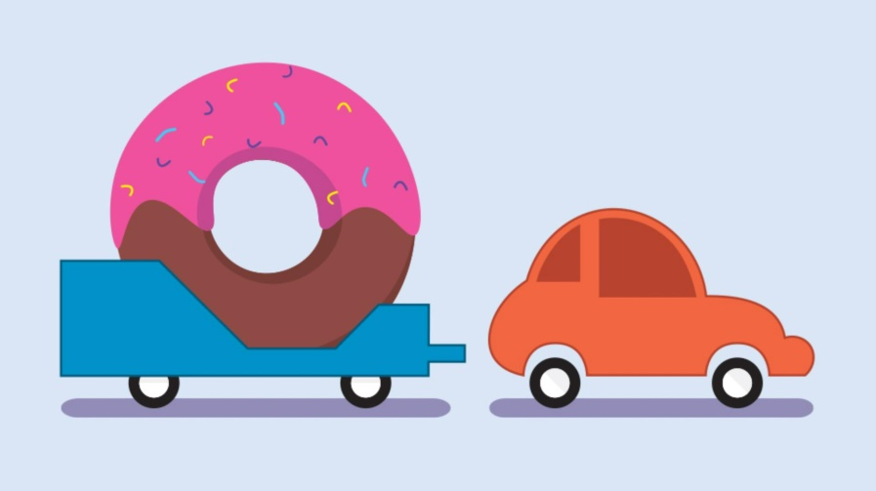

Create the Donut
    - using the Ellipse Tool while holding Shift to make it perfect.
    - Draw Inner Circle (for the hole) and center it.
    - Add Frosting:
    - Use the Pen Tool (P) to draw a wavy frosting shape covering the top half.
    - Fill pink color and add sprinkles using small, curved lines in various colors.

Create the Trailer
    - Use the Rectangle Tool (M) to draw the base.
    - Add angular shapes to give it the look from the image (you can draw these with the Pen Tool or combine rectangles and use the Shape Builder Tool).
    - Add two small wheels using the Ellipse Tool, fill with black/white, and group them.
    - Place the donut on top of the trailer and center it.

Draw the Car
    - Use rounded rectangles and ellipses for the body.
    - The main car shape can be made from a large rounded rectangle.
    - Use direct selection tool (A) to modify anchor points for curves.
    - Add windows using the Pen Tool or rectangles with curved corners.
    - Add wheels similarly to the trailer.
    - Use a solid fill for each part, similar to the orange/red colors in the image.

Create Shadows
    - Use Ellipse Tool to make ovals under the car and trailer.
    - Fill with a gray color and reduce opacity (~30%) to simulate shadows.

Assemble the Scene
    - Align the trailer behind the car and slightly overlap the hitch.
    - Use the Align Panel to line everything up horizontally.
    - Adjust layering (Object → Arrange → Bring to Front/Back) as needed.

Final Touches
    - Add a background color using a rectangle the size of your artboard.
    - Check stroke weights and colors for consistency.
    - Group each object (car, trailer, donut) for easy movement.

