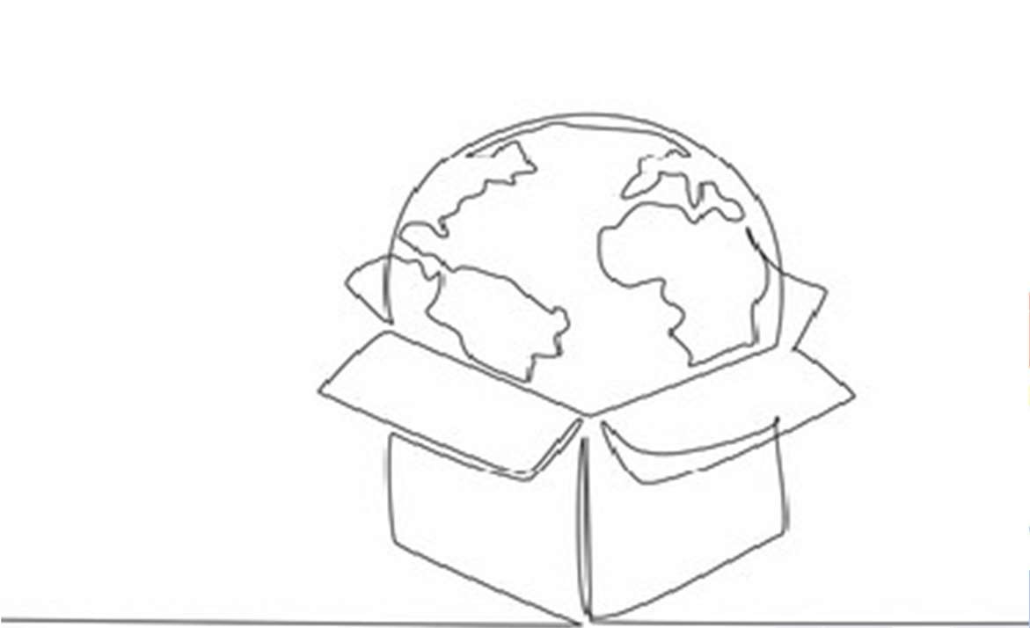

- Set Up Your Document
  - Open Adobe Illustrator.
  - Create a new document (choose A4 or your desired size).
  - Drag and drop your reference image into Illustrator, then lock the layer
so you don't accidentally move it.
  - Create a new layer above it to draw on.

Use the Pen Tool to Trace the Outline
  - Select the Pen Tool (P).
  - Start tracing the image using a single continuous line approach
  - Make sure to trace:
  - The box (including folds and edges).
  - The globe (circular shape).
  - The continents (rough outline of recognizable landmasses).

Adjust Line Stroke
  - Select your paths.
  - Go to the Properties panel > adjust Stroke.
  - Choose a black stroke with no fill to mimic the sketch style.

- Refine Your Paths
  - Use the Direct Selection Tool (A) to adjust anchor points and curves.
  - Smooth out any sharp edges using the Smooth .

Optional: Make It Look Like a Continuous Line
  - Connect all shapes (if stylistically accurate) into one continuous line by:
  - Merging anchor points.
  - Avoiding breaks unless absolutely necessary.

Final Touches
  - Hide or delete the reference image layer.
  - Zoom in and fine-tune any wobbly lines.
  - Save your file:
  - As an .AI for editing.
  - Export to .PNG, .JPG, or .PDF as needed.

