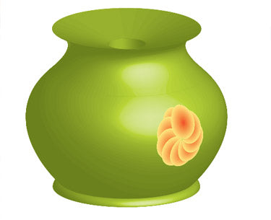

- Draw the Pot
- Use the Pen Tool (P) or Ellipse Tool (L) to create half the pot shape.
- Reflect it (Object > Transform > Reflect) and join both halves.
- Add Gradient
- Select pot shape.
- Apply a green radial or linear gradient using the Gradient Panel.
- Add Highlights and Shadows
- Draw shapes with light/dark green.
- Adjust opacity or use Soft Light blending mode.
- Create the Top Hole
- Draw -to-light green gradient for depth.
- Make the Flower
- Draw a petal using the Pen Tool.
- Fill with orange-yellow gradient.
- Use Effect > Distort & Transform > Transform to rotate and duplicate into a flower.
- Place Flower on Pot
- Position it on the side.
- Adjust size and opacity if needed.

- Final Touch
- Apply Gaussian Blur (optional).
- Group all (Ctrl+G) and save.Workspace

