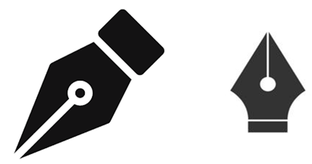

1. Choose a Tool
• Pick where you want to create your assignment:
• Word (MS Word or Google Docs)
• PowerPoint (for a more visual presentation)
• Canva (for creative layouts)

2. Insert the Images
• Upload or insert the two pen nib images into the document.
• Go to Insert > Image > Upload from computer
• Select both uploaded images:
• fountain-pen-nib-glyph-icon.jpg
• images.png

3. Resize the Images

• To ensure consistency and readability, resize the images. Here's a suggestion:
• Size:
• Width: 4 cm or 150 px
• Maintain aspect ratio to avoid distortion
• Click the image
• Use corner handles to resize proportionally
• Or right-click → Size and Position (Word) to enter exact dimensions

4. Label or Describe the Images
• Below each image, write a short description:

5. Add a Title and Introduction

• At the top of the assignment, write:
• Title: Comparison of Fountain Pen Nib Icons

6. Export or Submit
• When you're done:
• Save as PDF if required
• Print or share digitally

