



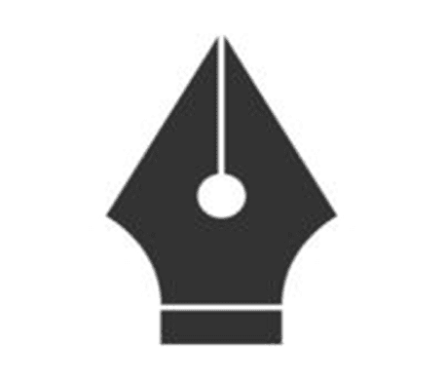
Self-Made Assignment – Adobe Illustrator
1
Workspace and Interface Customization

- Choose a Tool
- Pick where you want to create your assignment:
- Word (MS Word or Google Docs)
- PowerPoint (for a more visual presentation)
- Canva (for creative layouts)

Insert the Images
- Upload or insert the two pen nib images into the document.
- Go to Insert > Image > Upload from computer
- Select both uploaded images:
- fountain-pen-nib-glyph-icon.jpg
- images.png

- Resize the Images

- To ensure consistency and readability, resize the images. Here's a suggestion:
- Size:
- Width: 4 cm or 150 px
- Maintain aspect ratio to avoid distortion
- Click the image
- Use corner handles to resize proportionally
- Or right-click → Size and Position (Word) to enter exact dimensions

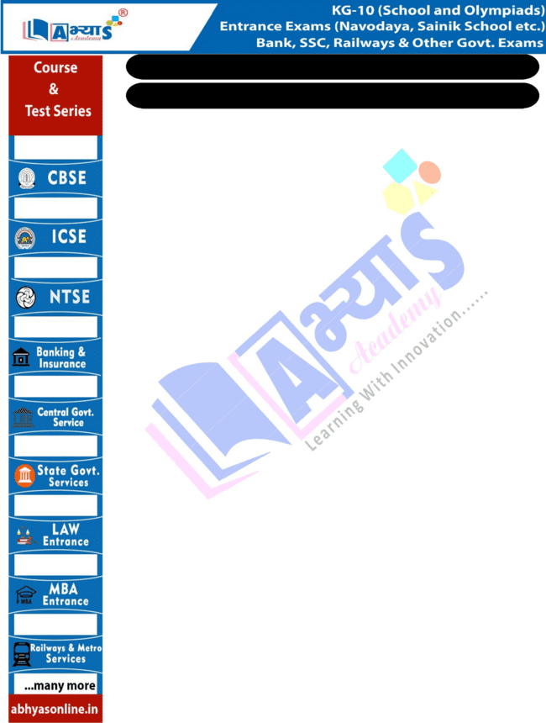
Self-Made Assignment – Adobe Illustrator
Workspace and Interface Customization

Label or Describe the Images
- Below each image, write a short description:

Add a Title and Introduction

  - At the top of the assignment, write:
  - Title: Comparison of Fountain Pen Nib Icons

- Export or Submit
1
- When you're done:
- Save as PDF if required
- Print or share digitally

