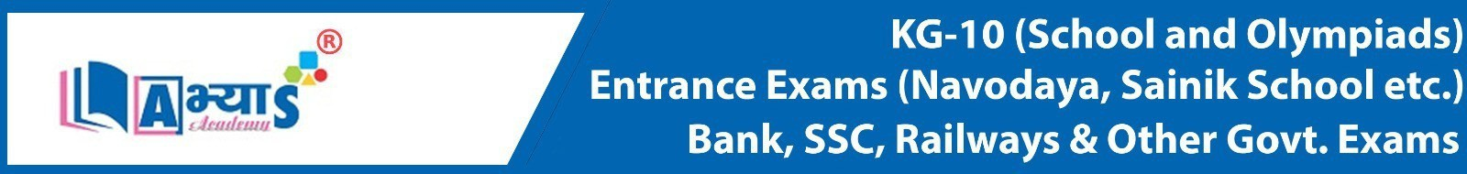
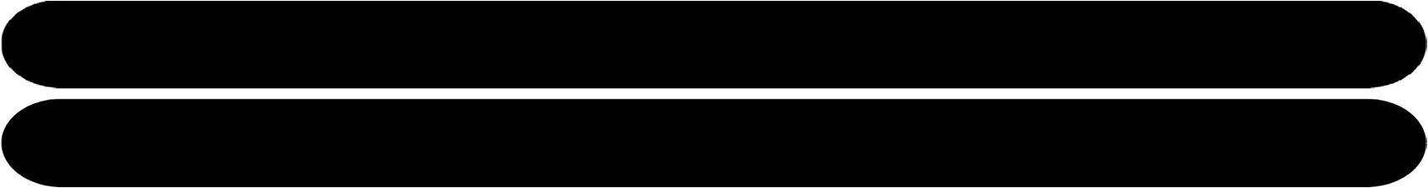


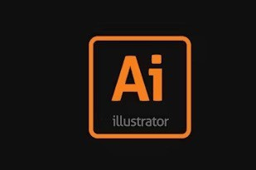

Self-Made Assignment – Adobe Illustrator Overview of Vector Graphics for Adobe Illustrator
1

Create a new document
- Width: 512 px
- Height: 512 px
- Color Mode: RGB
- Background: Transparent or black

Step 1: Background
- Select the Rectangle Tool (M)
- Click on the canvas and input:
- Width: 512 px
- Height: 512 px
- Set Fill Color: #1e1e1e (dark gray/black)
- Send it to back: Right-click > Arrange > Send to Back

Step 2: Orange Border Box
- Draw another rectangle:
- Width: 440 px
- Height: 440 px
- Align it to the center of the artboard using the Align panel
- Remove fill color, and set Stroke color: #ff9a00
- Set Stroke weight: 8 pt
- Give it rounded corners:
- Go to Properties panel > Corner Radius: 20 px



Self-Made Assignment – Adobe Illustrator
1

Overview of Vector Graphics for Adobe Illustrator

Step 3: "Ai" Text
  - Select the Type Tool (T)
  - Click inside the orange square and type Ai
  - Set font:
  - Font: Adobe Clean Bold (or use Myriad Pro Bold as a close alternative)
  - Font Size: around 130 pt (adjust as needed to center it well)
  - Fill Color: #ff9a00
  - Align the text to center both vertically and horizontally

Step 4: "illustrator" Text
  - Use the Type Tool (T) again
  - Type illustrator below the “Ai” text
  - Set font:
  - Font: Adobe Clean Regular (or Myriad Pro Regular)
  - Font Size: around 24 pt
  - Fill Color: #7d7d7d
  - Position it just under the "Ai" text, centered

Final Touches
  - Make sure everything is centered using Align to Artboard
  - Group all elements: Select All > Right Click > Group

Optional: Export
  - Go to File > Export > Export for Screens
  - Choose PNG, JPEG, or SVG as needed

