
Self Made Assignment – CorelDRAW
Using Grids,Guidelines and Shaping Tools for Precision
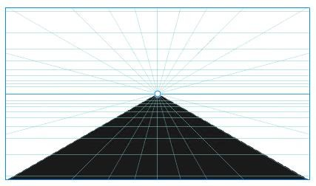

Step 1: Set Up Your Document

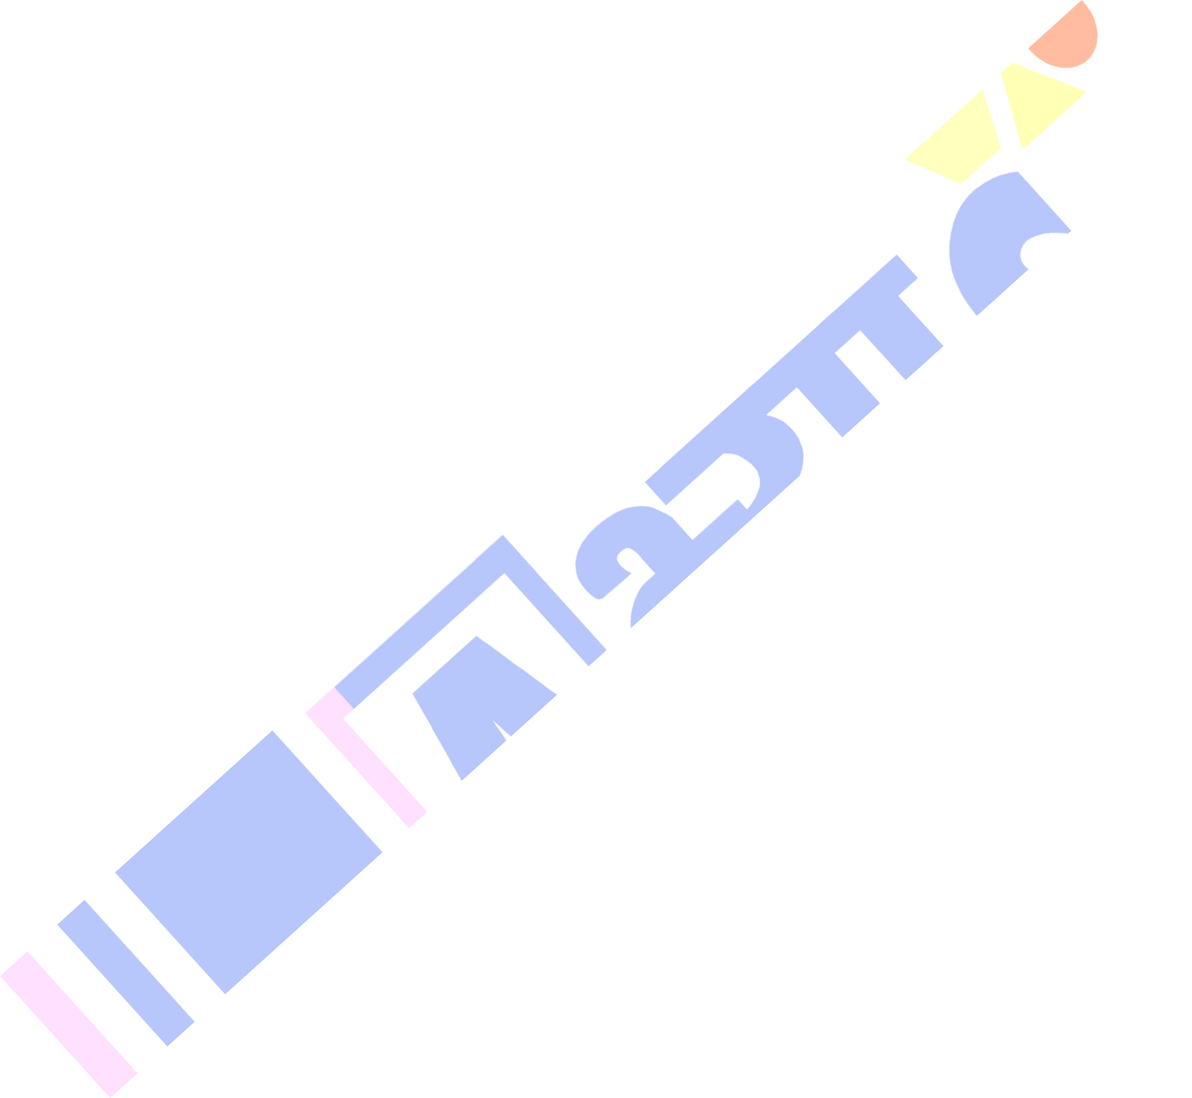


- Open CorelDRAW.
- Create a new document:
- Width: 800 px
- Height: 480 px (or whatever aspect ratio you prefer; match the image aspect ratio).
- Units: Pixels
- Resolution: 300 dpi (optional, for print clarity)
- Enable Snap to Objects from the View menu for easier alignment.

Step 2: Draw the Horizon Line & Vanishing Point
- Use the Freehand Tool (F5) or 2-Point Line Tool to draw a horizontal line
across the center of the canvas (this is the horizon line).
- Place a small circle or dot at the center of that line – this is your vanishing point.
- You can draw it using the Ellipse Tool (F7) while holding Ctrl to make it perfect.
- Size: Around 6x6 px.

Step 3: Draw Perspective Lines (Converging to Vanishing Point)
- Use the 2-Point Line Tool to draw straight lines from the vanishing point to the bottom of the page (this forms the triangle effect).
- Start drawing from the vanishing point to:
- Left corner
- Right corner
- Then keep adding more lines between them (about 10–15 on each side).
- This creates the radial lines of the perspective grid.

Self Made Assignment – CorelDRAW
Using Grids,Guidelines and Shaping Tools for Precision

Step 4: Draw Horizontal Lines (Spacing Compression)
- Use the 2-Point Line Tool again to draw horizontal lines across the radial lines.
- Start drawing from the bottom to the horizon line.
- Increase the density of the lines as you move closer to the vanishing point to simulate depth.
- For realism, each horizontal line should get progressively closer.
- You can duplicate lines with Ctrl + D and adjust spacing manually.

Step 5: Fill the Bottom Area with Black (Optional)
- Use the Bezier Tool or Freehand Tool to trace the triangular area between the two outermost radial lines.
- Close the shape at the bottom.
- Fill this shape with black using the Fill Tool (F11 or Fill Color dialog).

Step 6: Fine-Tuning
  - Use Object Manager (Window > Dockers > Object Manager) to organize your lines and layers.
  - Group (Ctrl + G) your lines if needed.
  - Use the Pick Tool to align and adjust any misplaced elements.

