
Self-Made Assignment – CorelDRAW
Advanced Object Management
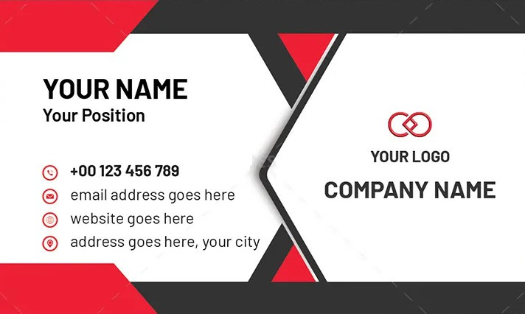


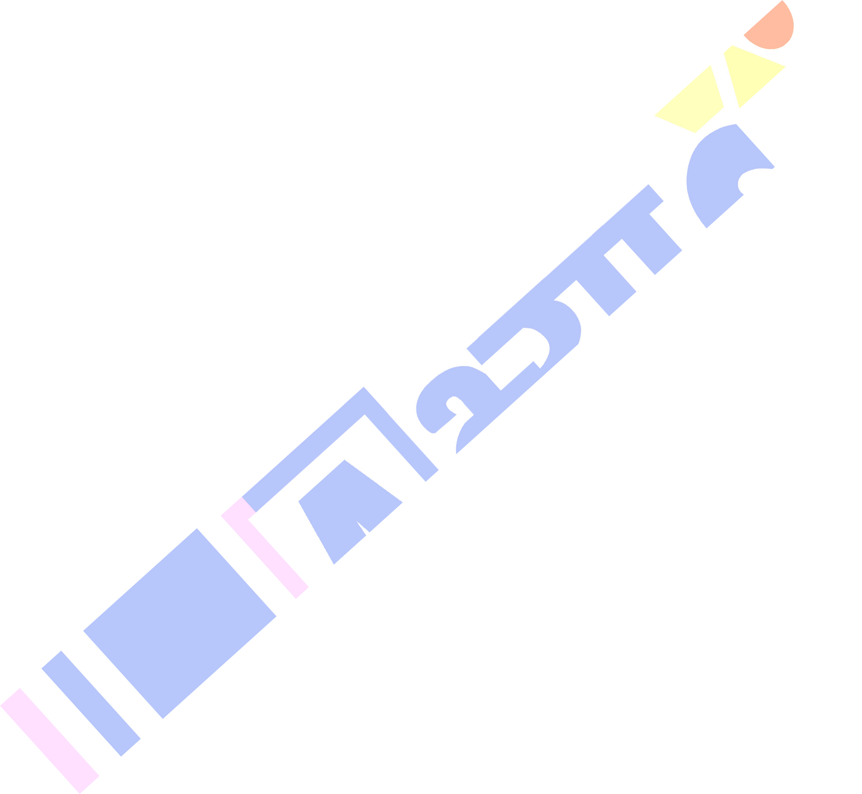
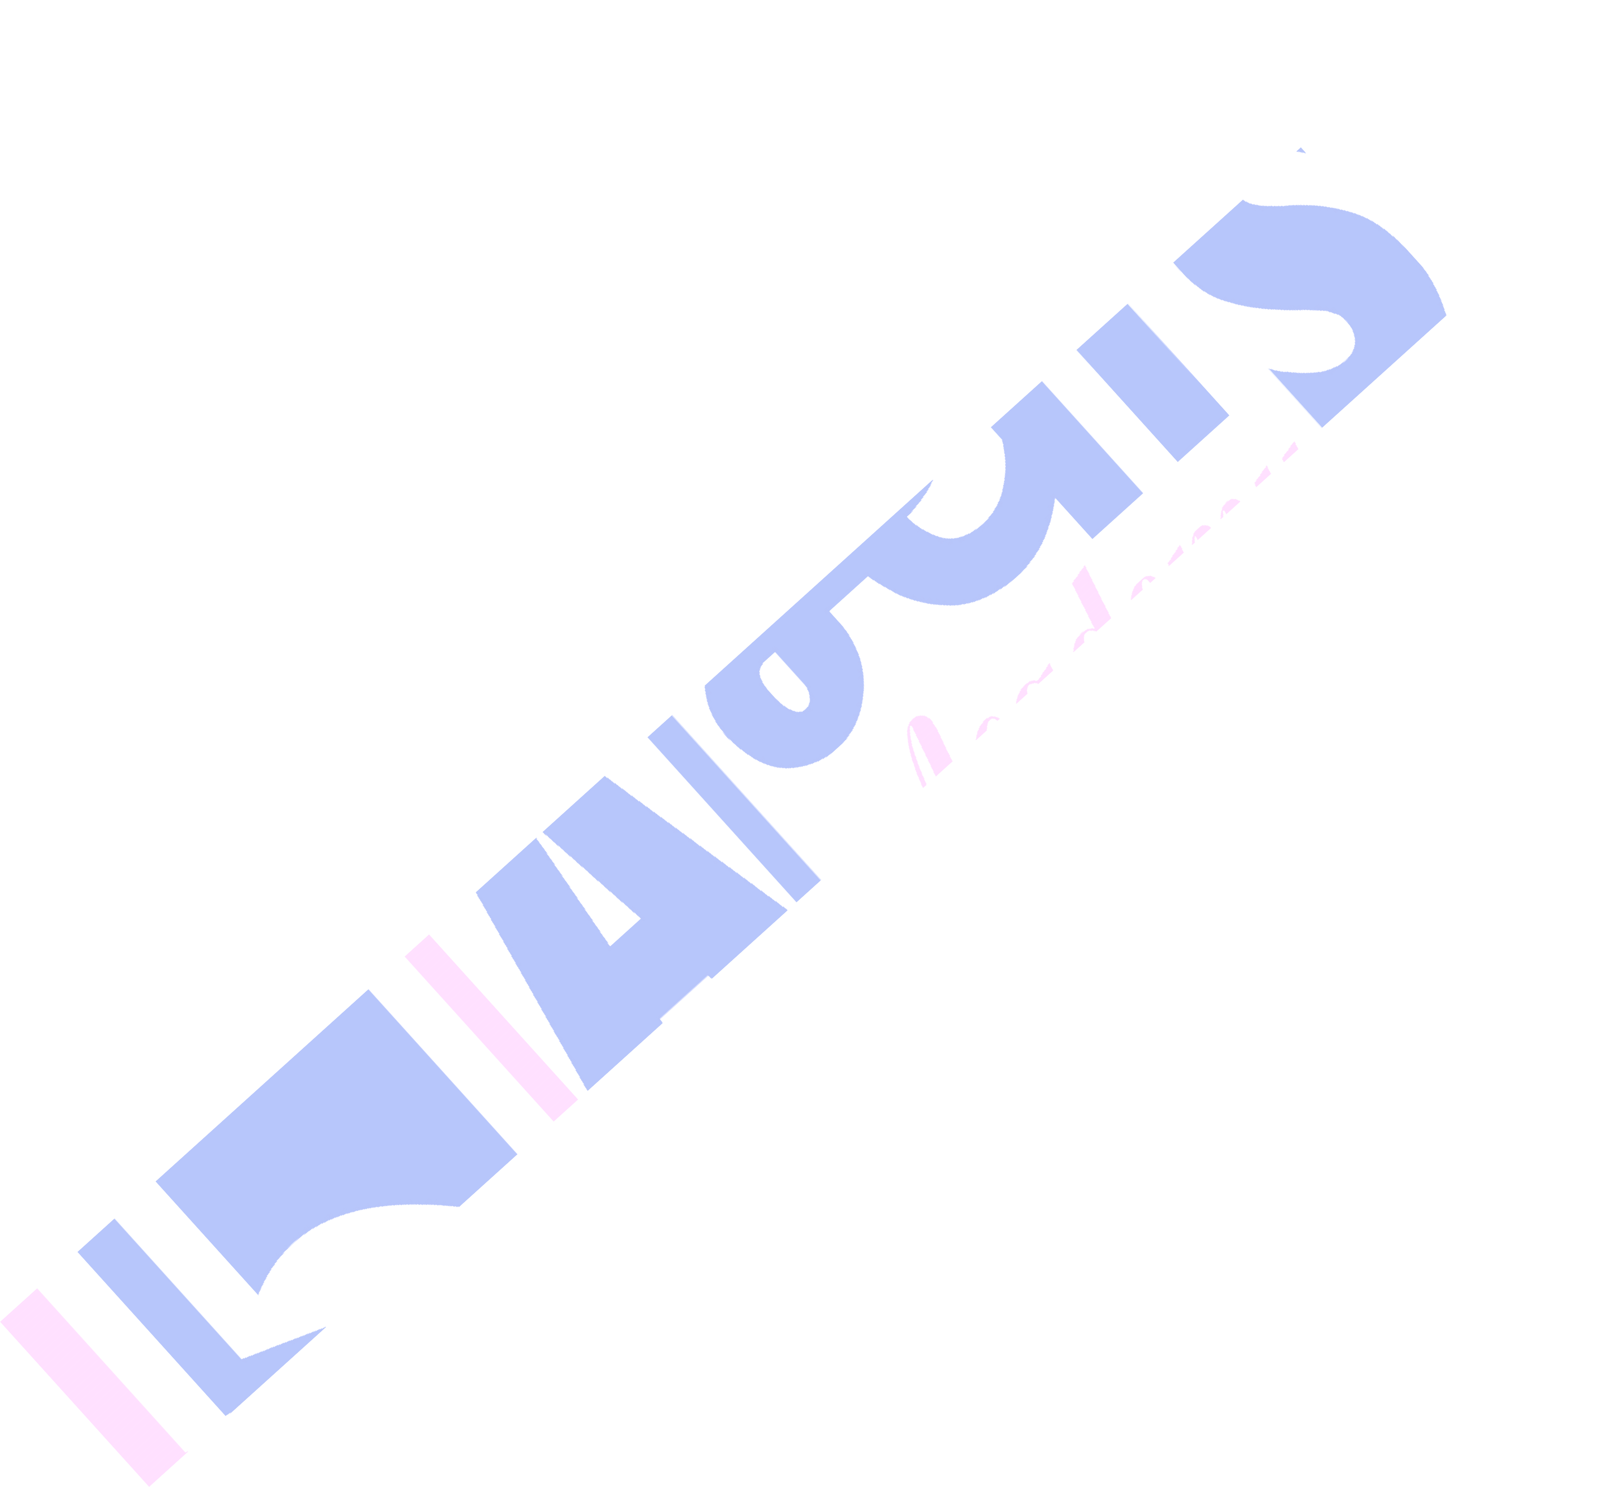

Set Up Document
  - Open CorelDRAW.
  - Go to File > New.
  - Set units to Pixels.
  - Set page size:Width: 1050 pixels,Height: 600 pixels
  - Orientation:Landscape.

Create Background Base
  - Select the Rectangle Tool (F6).
  - Draw a rectangle: 1050 x 600 px.
  - Fill: White.
  - Remove outline (Right-click the “No Color” swatch in the color palette).

Draw the Dark Top-Left and Bottom-Right Shapes
  - Use the Bezier Tool or Freehand Tool:
  - Draw two trapezoid-like shapes:
  - Top-left: 1 black shape slanting inwards.
  - Bottom-right: a mirrored black shape.
  - Fill: Black (#1D1D1D or similar).
  - Use red triangles (see next step).

Self-Made Assignment – CorelDRAW
Advanced Object Management

Draw Red Triangles (Accent Shapes)
  - Use the Polygon Tool or draw manually with the Bezier Tool.
  - Position:
  - Top-center.
  - Bottom-center.
  - Along the left and right edges.
  - Fill color: Red (#E60000 or similar).

Create Center White Hexagon Panel
  - Draw a Hexagon using the Polygon Tool (6 sides).
  - Convert to curves: Ctrl + Q.
  - Stretch and reshape to match the angled white section.
  - Duplicate and rotate/mirror for both left and right halves.
  - Fill: White.
  - Add a gray shadow line on the center seam using Drop Shadow Tool or a thin gray line.

Add Logo and Company Info (Right Side)
  - Use the Text Tool (F8) to insert:
  - "YOUR LOGO" (small, gray text).
  - "COMPANY NAME" (bold, large).
  - Import or draw a placeholder logo icon (use Ellipse + Intersect tools or import an SVG).
  - Align everything centered on the right side.

Add Name and Contact Info (Left Side)
  - Use Text Tool (F8):
  - Name: Bold and large.
  - Position: Regular or Light font.
  - Contact info lines:
  - Use a simple icon + text format.
  - Icons: Use a symbol font like FontAwesome, Wingdings, or import SVG icons.
  - Line 1: Phone number
  - Line 2: Email address
  - Line 3: Website
  - Line 4: Address
  - Suggested icon sizes: 18–22 px.

Self-Made Assignment – CorelDRAW
Advanced Object Management

Font Styling
  - Use modern sans-serif fonts for clarity:
  - Suggested fonts:
  - Montserrat, Poppins, Arial, or Roboto
  - Font sizes:
  - Name: 36–40 px
  - Title: 20–24 px
  - Contact info: 18–22 px
  - Company name: 38–42 px

Align and Group
  - Use Align and Distribute (Arrange > Align and Distribute) to ensure all elements are evenly spaced and aligned.
  - Use guidelines or rulers to align left and right sections perfectly.
  - Group sections if needed using Ctrl + G.

Export for Print or Web
  - Go to File > Export.
  - Choose PNG, JPG, or PDF.
  - Resolution: 300 DPI for print.
  - Enable bleed area (typically 30 px around edges) if needed.

