Instruction/Tasks:  1. Make the above slides with Title and Content as given.  2. Use Red Color for the Heading in all Slides  3. Use Bold, Italic and Underline as per your choice.  4. Convert the presentation from Normal View to slide sorter.  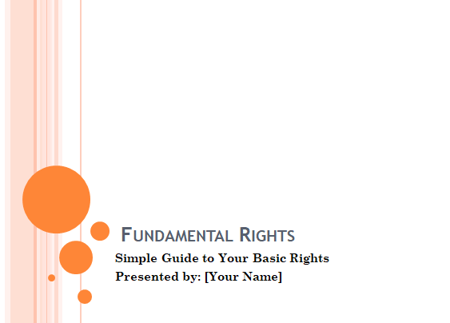 | Slide 1: Title Slide
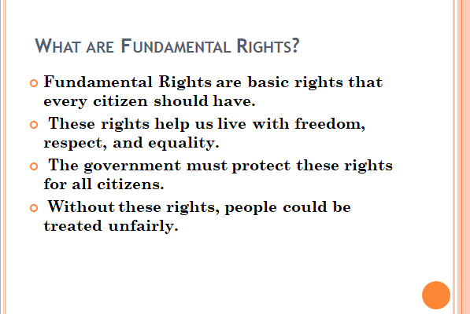 | Slide 2: Title and content
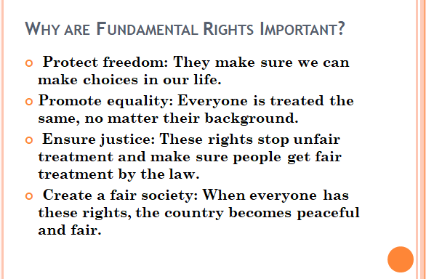 | Slide 3: Title And content
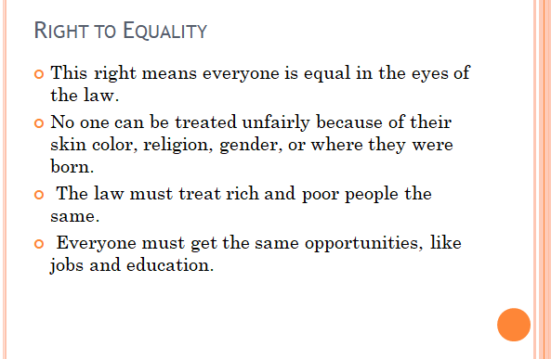 | Slide 4: Title and content
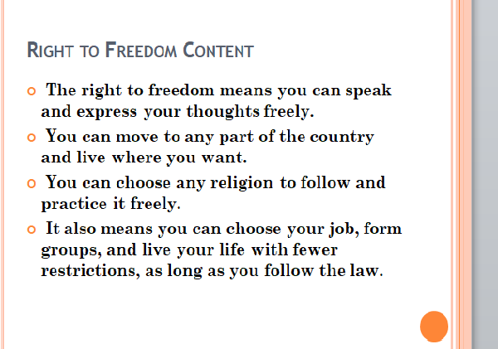 | Slide 5: Title and content
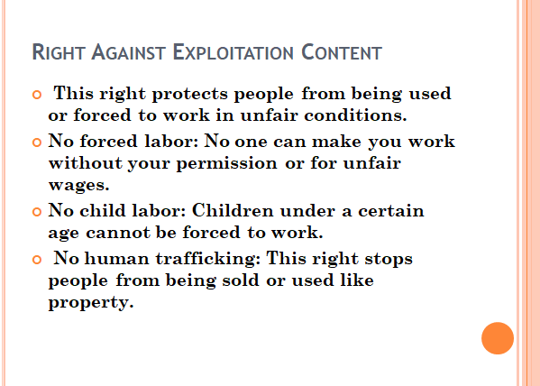 | Slide 6: Title and content
 | Slide 7: Title and content
 | Slide 8: Title and content

