
Self-Made Assignment – CorelDRAW
Setting Up Page Layout and Orientation
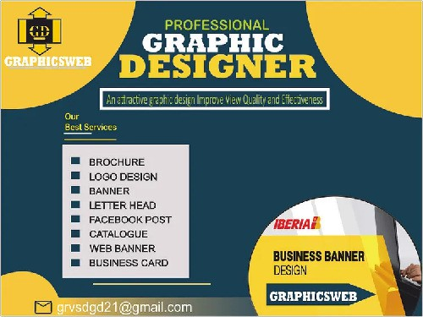


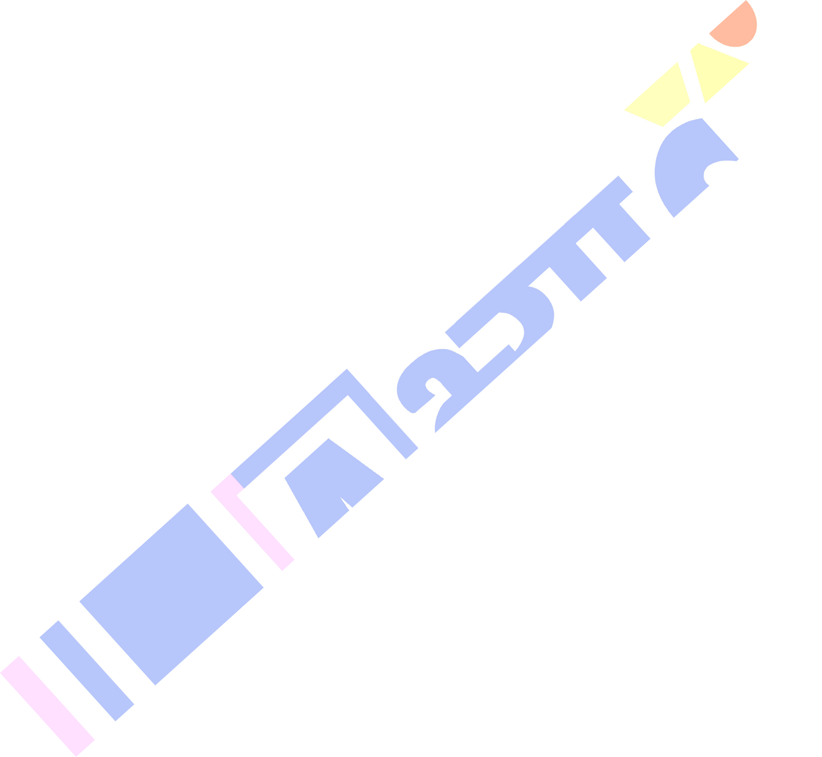
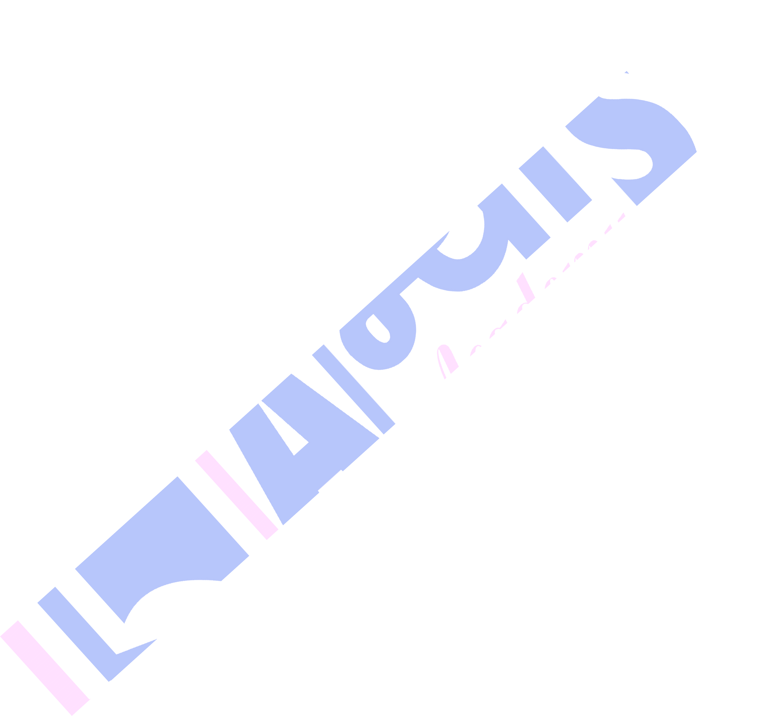

Document Size
- You can set a standard size for posters, such as:
- Landscape Mode: 1920 × 1080 pixels

Open CorelDRAW
  - Create a new document.
  - Set the size: 1920px (width) × 1080px (height)
  - Set Orientation: Landscape
  - Color Mode: RGB (for digital use)

Background Design
  - Use the Ellipse Tool (F7) to create large yellow semi-circles.
  - Arrange them at the corners as in the design.
  - Fill the background with a dark blue/navy rectangle using the Rectangle Tool (F6).

Self-Made Assignment – CorelDRAW
Navigating the Workspace and Viewing Designs

Top Section - Logo & Title
  - Create the GRAPHICSWEB logo using basic shapes (rectangle, circle, and lines) and text tool (F8).
  - Use white and yellow for the logo and label.
  - For the title:
  - Use 3 Text Boxes:
  - "PROFESSIONAL" in green (small size)
  - "GRAPHIC" in white bold
  - "DESIGNER" in yellow bold
  - Align these centrally using alignment tools (Ctrl+Shift+A).

Slogan Bar
  - Add a small rectangle below the title.
  - Insert text: "An attractive graphic design Improve View Quality and Effectiveness"
  - Use a green background and light text.

Right Section - Business Banner
  - Add a circle image holder using the Ellipse Tool.
  - Use the PowerClip feature to place an image inside the circle:
  - Right-click image → PowerClip Inside → click the circle
  - Add the Iberia logo on top-left of the circle (optional placeholder logo).
  - Create a yellow rectangle for the "Business Banner Design" text.
  - Place the "GRAPHICSWEB" text bar below in a blue rectangle.

Contact Information
  - Use a yellow rectangle at the bottom-left.
  - Place an email icon (you can use a symbol font or import an SVG).
  - Add the email: grvsdgd21@gmail.com

Fonts
  - Headings: Impact, Montserrat Bold, or Bebas Neue
  - Body: Arial, Roboto, or Calibri

Exporting
  - File- Export-Choose PNG/JPEG

