Task: Print the Table of a Number Entered by the User

Write a C program that asks the user to enter a number, and then uses a for loop to print the multiplication table of that number up to 10 times.

Instructions:
- Ask the user to enter a number.
- Use a for loop to repeat from 1 to 10.
- In each loop, multiply the number with the current loop value.
- Print the result in this format:
number x current = result

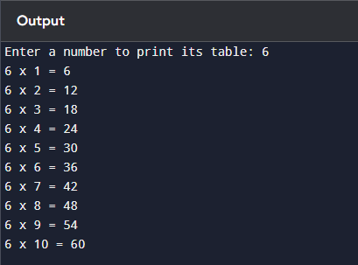
Resultant Output:

