Task:
You are asked to create a program that calculates the total and average marks of a student in 3 subjects — Math, Science, and English.

Requirements:
- Ask the user to enter marks out of 100 for the 3 subjects.
- Use arithmetic operators to calculate:
  - Total marks
  - Average marks
- Display:
        - The total marks
        - The average

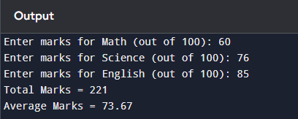
Output Screen:

