


1
Self-Made Assignment – MS Power Point A
Using Slide Master in Power Point

Make this presentation using slide master

 |   Slide 1: Title Slide
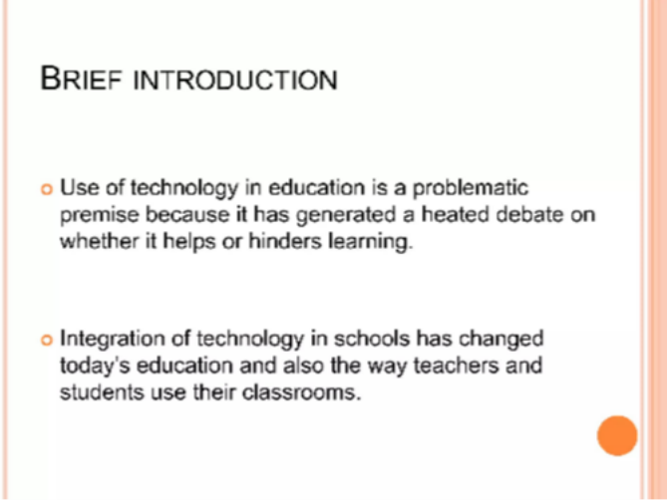 | Slide 2:  Title and Content Slide
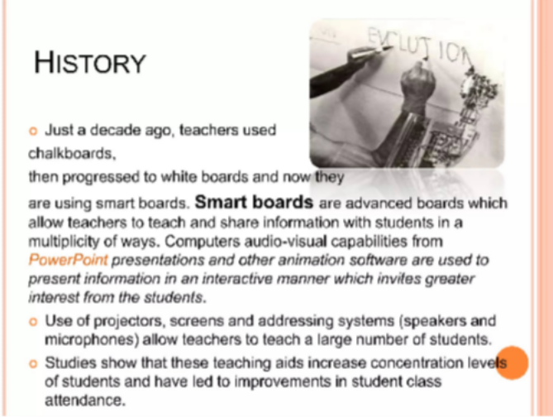 | Slide 3:  Title and Content Slide

1 of 3



2
Self-Made Assignment – MS Power Point A
Using Slide Master in Power Point

Slide 4: Blank Slide

Slide 5: Blank Slide

2 of 3

3
Self-Made Assignment – MS Power Point A
Using Slide Master in Power Point

Instructions/Task:

- Open PowerPoint and create a new blank presentation.
- Click on the “View” tab on the Ribbon.
- Select “Slide Master”.
This opens the Slide Master view where you can edit the master layout.
- In the Slide Master view:
  - Select the top (main) master slide.
  - Change the font style to Arial and size to 12 for the title and content.
  - Apply a theme Oriel

- Once done, click “Close Master View” on the Ribbon.

3 of 3

