Make this presentation adding header and footer in presentation
 | Slide 1:  Title Slide
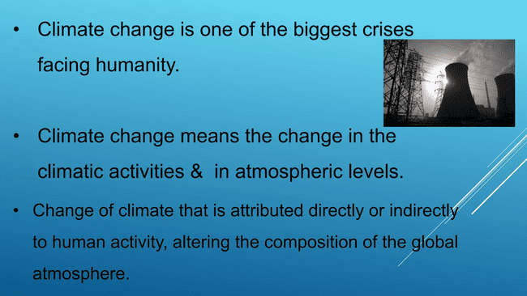 | Slide 2:  Title and Content Slide
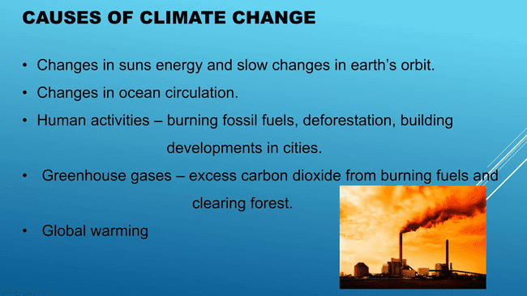 | Slide 3:  Title and Content Slide

 | Slide 4:  Blank Slide
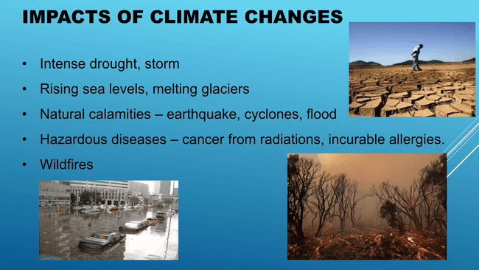 | Slide 5:  Title and Content Slide
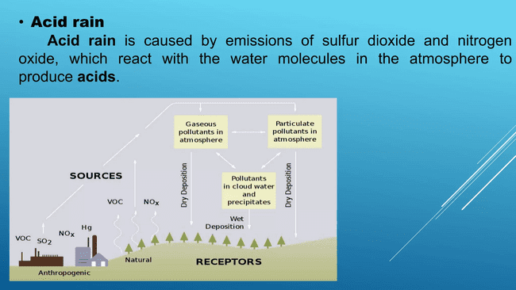 | Slide 6:  Title and Content Slide

Instructions/Task:
- Header (Common for All Slides):
Text: Climate Change
  - Place it at the top center of each slide.
  - Use a clean font like Arial or Calibri (size 16-18).
- Footer (Common for All Slides):
- Left Side: Your Name
- Right Side: Slide number.
- Apply Slice Theme to all the Slides.

