Make this Following Text Box Assignment in PowerPoint
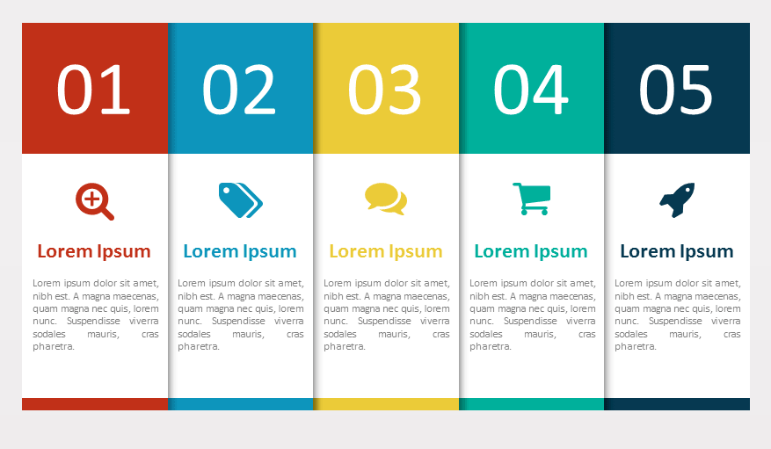
Follow This Following Instructions
- Make this Text Box.
- Using Shape Fill.
- Using Shape Outline.
- And add Pictures in this text box.
Instant Messaging
Search Box
Tag
Shopping
Airplane Mode

